HERO of the MONTH

Barnabas Akantambira
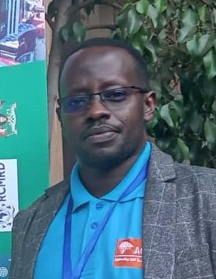
- What is your background?
Country Coordinator ACLENet based in Uganda-Africa, worked as western Uganda manager for relief international and project director for compassion international for over 7 years.
Have a postgraduate and 1st degree in Uganda.
- How and when did you hear about ACLENet?
I discovered ACLENet through Richard Tushemereirwe.
- What motivated you to work with ACLENet?
Educating people and protecting lives from unknown killer lightning.
- Please describe your work with ACLENet.
Coordinate every activity of ACLENet concerning Uganda.
- What are some of your key achievements so far with ACLENet?
Completed protection of Mongoyo primary school, surveyed more schools, created advocacy groups both at local and national levels and many more.
- What are some of the challenges you have encountered in your work with ACLENet? How have you addressed these challenges.
The most challenging situation is changing the perception of most Africans to believe what Lightning is from what they were taught by their culture.

I have seen people change at a slow speed through sensitization and education programs over TV and radio presentations.
- How would you like to see ACLENet develop in the future?
I would like to see ACLENet expand to all Africa countries and many other people coming on board to make this knowledge accessible to everyone and more so, to other countries beyond Africa to be protected.
- What do you see in the future for ACLENet regarding lightning safety?
I see ACLENet as a very big, known, recognized, and supported by both government and non-government agencies all over the world.
- Encouragement note
I encourage the founders and all volunteers to keep up the spirit for the work is very important and highly needed by humanity.
- Is there anything else you would like to include – personal information, family, goals, etc? Is it ok to list your email?
Yes, Thank you. Barnabas Akantambira <ak.barna@yahoo.com>

THANK YOU for all you do for ACLENet and for saving lives - MA

