HERO of the MONTH – 2023-08

Paola Luria

Flash translator for Portuguese

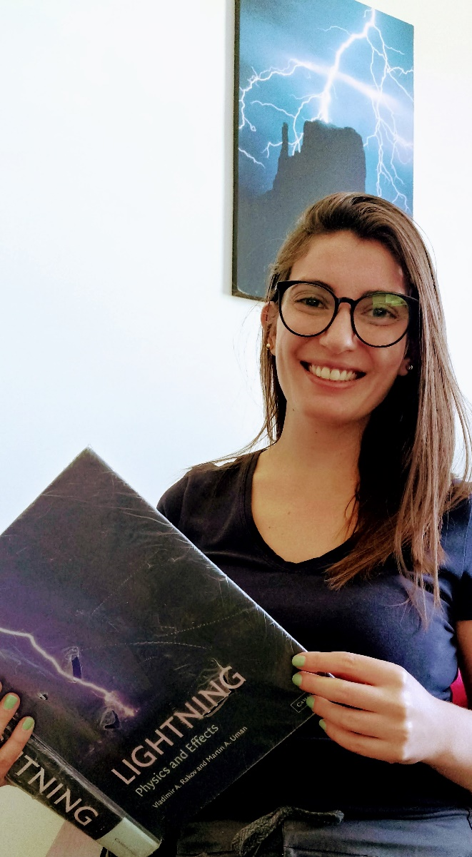
- What is your background?
PhD student in Space Geophysics at INPE, Brazil. I've always been in love with lightning. I seek to understand its physical properties and how a discharge behaves when reaching a structure or surface, in order to provide information/subsidies for lightning protection systems.
- How and when did you hear about ACLENet?
I discovered ACLENet through Dr. MACooper.
- What motivated you to work with ACLENet?
Being able to volunteer even from distance.
- Please describe your work with ACLENet.
Translator of newsletters into Brazilian Portuguese.
- What are some of your key achievements so far with ACLENet?
Understand more about the situation of the population outside my country.
- What are some of the challenges you have encountered in your work with ACLENet? How have you addressed these challenges.
The biggest challenge was seeing the difficulty that people in Africa go through and trying to understand why this happens. Why the world is not fairer and less unequal. Whenever I see people dying due to lack of information, or most of the time structure, it breaks my heart.
- How would you like to see ACLENet develop in the future?
I would like ACLENet to expand to many other regions where caring for others is needed and for many more collaborators to be able to help this cause.
- What do you see in the future for ACLENet regarding lightning safety?
ACLENet has done excellent work with regard to lightning safety in Africa. I believe that in the future the project tends to grow and gain strength.

- Encouragement note
Congratulations to the creators of the project. More vulnerable people need incentives like this. Many people have been made aware and lives have already been saved.
- Is there anything else you would like to include – personal information, family, goals, etc? Is it ok to list your email?
Yes, you can list my e-mail - Paola Lauria lauriapb@gmail.com

THANK YOU for all you do for ACLENet and for saving lives - MAC

