KENNETH ROETS, Lightning Protection expert and member of ACLENet’s Lightning Protection Working Group

HERO of the MONTH for 2023-04

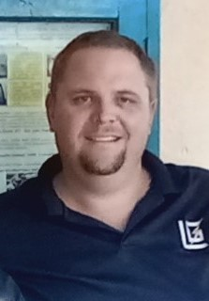

1. What is your background? I have been in the Lightning Protection industry for over 13 years saving lives and structures. I am part of the SANS 10313 WG. My organization, The Lightning Gurus (TLG), specializes in protecting solar sites where TLG has protected over 50MW of Solar projects.
2. How and when did you hear about ACLENet? I heard of ACLENet in 2017 when Alexis Barwise introduced me to the working group.
3. What motivated you to work with ACLENet? Saving people’s lives and structures from damage or losses
4. Please describe your work with ACLENet. I currently assist with the procurement of material to the projects in Africa at a reduced cost to make the project stay inline with the budgets allocated. I also am part of the technical committee discuss the projects in detail
5. What are some of your key achievements so far with ACLENet? Protecting 5 schools which has led to safety from Lightning effects. Also, education has been powerful in sharing knowledge with the community and allowing local parents of the schools to get involved with the installations.
6. What are some of the challenges you have encountered in your work with ACLENet? How have you addressed these challenges. The biggest challenges are the information that’s received from the schools. The information provided is sometimes inadequate and thus more information is required. We overcome the challenges by sending an ACLENet staff member to the sites to perform all tests and obtain photos from all the different sides of each building.
7. How would you like to see ACLENet develop in the future? I see ACLENet become the NPO that has protected the most lives as materials can be replaced but not people’s lives. Also, in the future ACLENet will not only protect countries like Uganda but will protect the whole of AFRICA.
8. What do you see in the future for ACLENet regarding lightning safety? I see that education will become more readily available to anyone that wants to learn about lightning and to protect. I look to the time when every school will be educated as well as the whole governments of every Afircan country will assist in promoting this education.