Martin Omara, ACLENet staff – and so much more!
Hero of the Month 2023-02
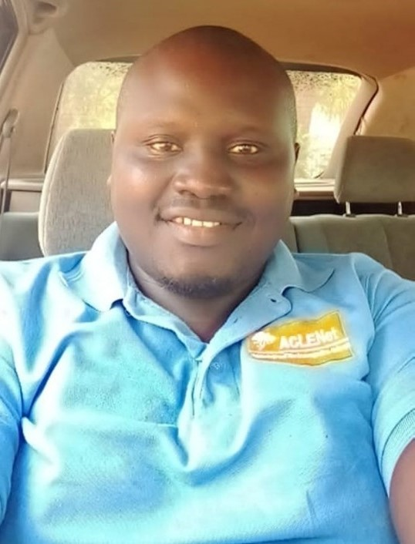
- What is your background?
My name is Omara Martin a Ugandan national, I am a self-motivated person who believes in teamwork. I attained my bachelor’s degree in Commerce (Accounting option) from Makerere university Kampala and graduated in 2010. Ever since I graduated in 2010 I gained vast experience working with NGO’s. I have worked for a number of organizations among them is Bayport financial services, Goodwill consultancy, Plan international Uganda, Ark for humanity South Sudan and finally ACLENet which I joined in 2016 up to date.

- How and when did you hear about ACLENet?
I heard about ACLENet in 2015 through one of the directors Mr. Richard Tushemereirwe

- What motivated you to work with ACLENet?
- At first what motivated me was the work environment where everyone treats the other as family and am able to express my views without any hardship or without someone puling me back. The love within the organization were they always work as a team and we keep consulting each other if need be.
- Working with great and enthusiastic people like; Mary Ann Cooper, Richard Tushemereirwe, Chandima Gomes, Ron Holle, Mitchell Guthrie, Ken Nixon, Ian Jandrel among other professionals at ACLENet board.
- I wanted to learn something new and develop my career. I didn’t know much about lightning but when I joined the organization I can now conduct a public education in lightning

- Please describe your work with ACLENet.
- I have managed ACLENet accounts for over 7years now and I have done it well though there may be some little challenges that are sometimes unavoidable. Among these I do several transactions like payments to responsible persons and doing financial reconciliations and preparing budgets and monthly expense reports.
- I have volunteered in many activities like schools’ survey, incidence investigation and LPS installations among others
- I was a project manager in the recently concluded LPS installations in one of the schools in northwest Uganda and it was completed and commissioned.
- I recently participated in the international conference on lightning protection which was help in Cape town, South Africa
- What are some of your key achievements so far with ACLENet?
- Successfully managing and completing LPS installations at mongoyo primary school.
- Timely monthly expense reports
- Successfully managing ACLENet account
- Preparing budgets
- Successfully conducting transactions like paying staff salaries among others
- Attending Ex-com and LPWG meetings
- Conducting successful lightning survey
- Emphasized teamwork among the staffs
- Participated at ICLP in Cape Town in South Africa
- Planning and preparing for staff meetings.
- Negotiating with casual workers in the field during LPS installations

- What are some of the challenges you have encountered in your work with ACLENet? How have you addressed these challenges?
- One of the challenge was the issue of transport but currently with Gods blessings we managed to acquire a RAV4 which will help us to move to the field and also help in moving from office to office as we conduct our activities.
- I had a challenge with my computer but recently Mary Ann cooper bought one for me and it’s still in perfect condition, thanks to MAC.
- I used to have a challenge with collecting receipts from staffs for their expenses but due to constant staff meetings we were able to address the issues.
- Previously I had a challenge with the bank the held our account which was only within Kampala so I needed to travel to Kampala to make a transaction but we have changed to a bank which is country wide and more so it has an online platform so I don’t need to go out to the bank to make a transaction, I just do it at the comfort of my home.
- Most of our staffs are committed with their jobs elsewhere due to the fact that we don’t have enough funds to keep them with us all the time but if we put in enough efforts we shall get the funds that can keep them with us only.

- How would you like to see ACLENet develop in the future?
- Prioritizing learning and development of staffs for better performance
- Staffs should be self-motivated to enable them take over from where elders of the organization have left them (young staffs should work hard to take up leadership roles)
- Performing more of research work in the field of lightning
- Emphasizing more on successful Grants writing, this will help the organization move forward.
- A strong emphasis on talent development.
- Encouraging teamwork among staffs for better performances
- Pushing for a collaboration with government ministries for higher performances.
- Pushing for a collaboration with other international organizations like UNICEF, Plan international and any other organization that do support programs like children’s education.

- What do you see in the future for ACLENet regarding lightning safety?
I see ACLENet championing in the field of lightning protection and education and research in the whole world, this can be done through carrying out constant research and connecting with several organization dealing in lightning programs or disaster risk management programs
- Encouragement note
I believe if we work together as a team of enthusiastic people and do more research and more grants Writing and fundraising, then we shall achieve the organizations goals and objectives.
Let us all be the leaders we wish we had.

- Is there anything else you would like to include – personal information, family, goals, etc? Is it ok to list your email?
My name is Omara Martin a Ugandan national, born on the 17th/08/1984 in lira a city found in Northern Uganda. I am married and I have 2 kids (boys)
- Do more research on lightning and do more LPS installations and carry out lightning education programs.
- My goal is to improve financial results in the organization
- Improving collaboration with colleagues
Contacts. +256 752 270 757/ +256 776 677 418
Email: omaramartinokodi@gmail.com/ omaramartinokodi@yahoo.com
(permission granted to list Martin’s email)

