[Local News](https://citizen.co.za/category/news/south-africa/local-news/) 20.12.2018 11:47 am

**Barberton High School burns to ashes after suspected lightning strike**

https://citizen.co.za/news/south-africa/local-news/2051737/barberton-high-school-burns-to-ashes-after-suspected-lightning-strike/

AddThis Sharing Buttons

Share to Facebook**12**Share to TwitterShare to WhatsAppShare to Email

CNS reporter

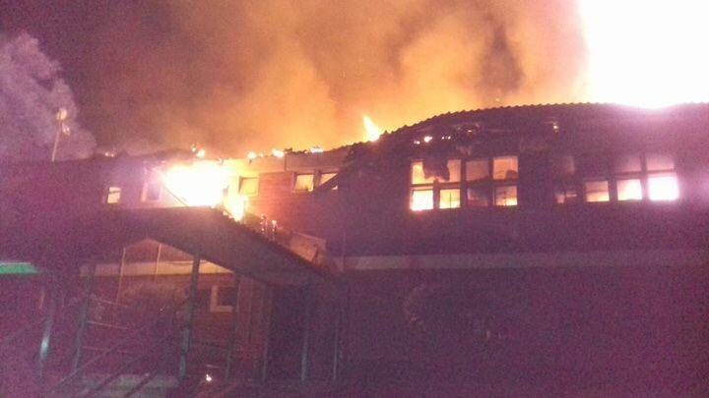

Image: Mpumalanga News.

**Forensic experts have been called to the scene to determine the cause of the devastating fire.**

The department of education in Mpumalanga confirmed the sad news of Barberton High School being destroyed by fire on Wednesday night, reports [Mpumalanga News](https://mpumalanganews.co.za/349814/barberton-high-school-burnt-ashes/).

It is suspected the school was struck by lightning. Spokesperson for the department Jasper Zwane said the cause of the tragedy is still under investigation.

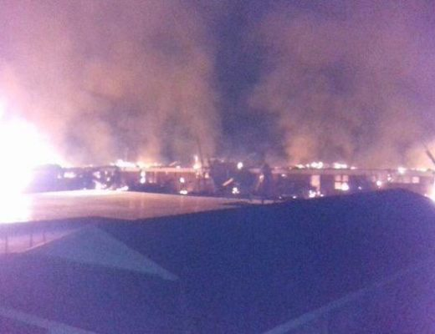

“We could not confirm the cause of the fire yet. Our team of officials had rushed to the scene this morning to get the facts of the matter,” he said.

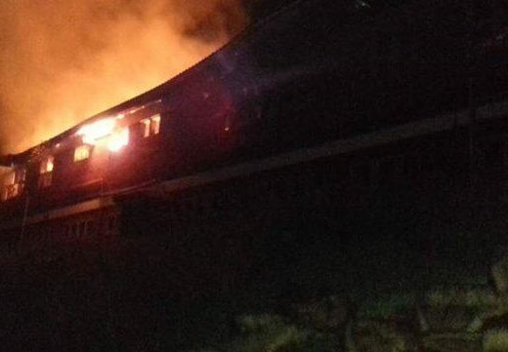

This is a developing story, updates to follow as more information becomes available.