Lightning has killed 49 herds of cattle in Limulunga [Zambia]
November 27, 2019
https://www.lusakatimes.com/2019/11/27/lightning-has-killed-49-herds-of-cattle-in-limulunga/

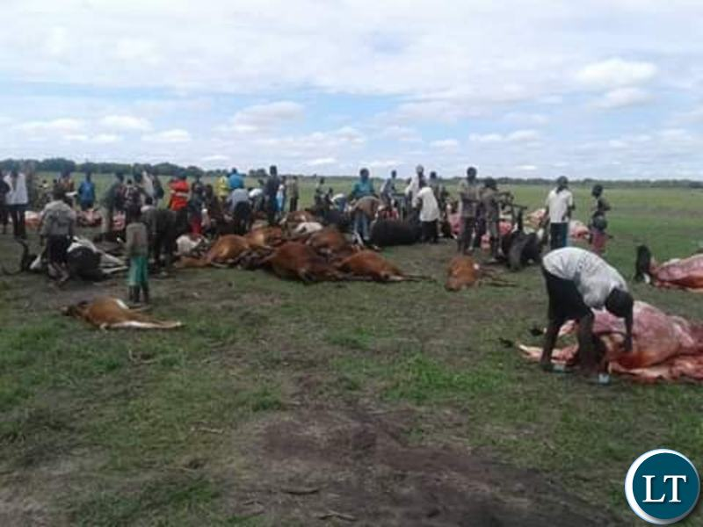
Lightning has killed 49 herds of cattle in a kraal of 90 animals in Ndiki area of Limulunga district in Western province.
This happened around 16 hours yesterday, lightning struck a kraal housing cattle belonging to Malebekwa Mbulai (91).
Mr. Mbulai, who was emotional charged said he wondered how lightning struck the animals that were under a tree which was however not affected at all.
He said the incident was strange considering the fact that the meat did not turn dark as usually is the case in lightning incidents.
The 91-year-old man said almost all the animals that died were oxen, which are used for transportation and ploughing.
He lamented that it will be difficult for him to till the land in the current farming season adding that many people in Ndiki area also depended on the same cattle for cultivating in their fields.
And an Environmental Health Technologist in Nangula, Humphrey Kankunga, who was at the scene after the incident, said the slain cattle could not be inspected in detail because animals that die in such a way were not safe for human consumption.
He explained that cattle, which are killed by lightning, have imperfect bleeding because the throat is only cut after the animals have already died.
Mr. Kankunga, who is also Nangula Rural Health Centre Officer-In-Charge, said two of the cattle which died belonged to the rural health centre and Ndiki safe motherhood action group (SMAG)
When asked if there was a way livestock farmers could avoid such unfortunate incidences in future, Mr. Kankunga said nothing could be done because lightning was natural occurrence.
Lightning is a naturally occurring electrostatic discharge during which two electrically charged regions in the atmosphere or ground temporarily equalize themselves, causing the instantaneous release of as much as one gigajoule of energy.

