Rubanda: School head teacher, 2 others killed by lightning
by Wilfred Arinda Nsheeka
https://www.watchdoguganda.com/news/20210925/122241/rubanda-school-head-teacher-2-others-killed-by-lightning.html
25th September 2021 at 11:41
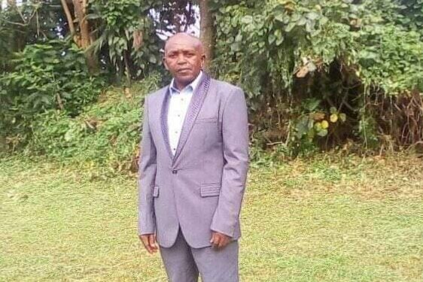
Owoyesiga Sunday, a head teacher was killed by lightning
Police in Rubanda District is investigating circumstances under which three people were killed by lightning on Friday.
Ben Kwikiriza male juvenile aged 16 resident of Kamusegwa cell Nyarurambi ward Rubanda town council and Stanley Owoyesiga Sunday,63 year,both died after being struck by lightning.
Owoyesiga has been the head teacher of Golden high school in Muko.
Another victim identified as Happy aged about 45 of Kamusegwa village Nyarurambi ward Rubanda town council was admitted at Muko health center four after sustaining serious injuries.
To know more about how you can buy an affordable home from Kabaka’s Mirembe estate Sentema, click here
The deceased met their death at Kamusegwa village while it was raining heavily.
In a separate incident that occurred at Karambo village in ikamiro Parish Muko subcounty, a one Bright Orikiriza 35 years was also struck dead by lightning.
This was during a heavy down pour when all these people were sheltering.
This case has been registered at Muko police station under file number 08/24/09/21.

