**RELATIVES OF TWINS KILLED BY LIGHTNING SEEK SPIRITUAL GUIDANCE**

**Zambia**

November 6, 2023

<https://zambianobserver.com/relatives-of-twins-killed-by-lightning-seek-spiritual-guidance/>

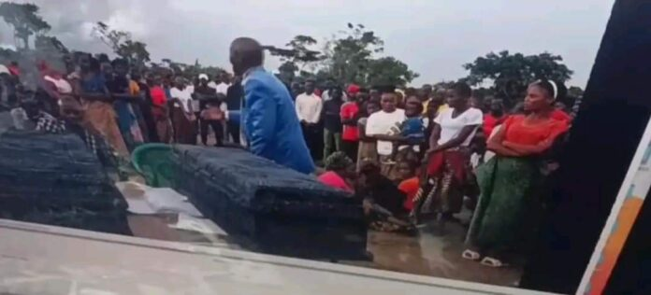

Yesterday, while they were burying the juvenile twins, some family members appealed to the community for help in determining who was responsible for the twins’ deaths, which they refused to accept as natural.

Twins aged eight perished last week after being hit by lightning in chief Munkanta’s Chiefdom of Kawambwa District of Luapula Province, with many refusing to accept their deaths as natural.

The twins, known as Obed Mpundu, died while playing together inside their home at around 06:00 hours on Friday, prompting locals to be suspicious.

Their family representative warned mourners during yesterday’s burial service about the person(s) responsible for their passing, pointing out that they would only turn to witchdoctors for answers.

Others have accused their biological father of being responsible for his twin boys’ deaths because he was away in Nakonde at the time the juvenile twins died.