Uwari uhagarariye CNLG muri Karongi na Rutsiro yapfuye akubiswe n’inkuba - RWANDA
Yanditswe na - FROM CITIZEN REPOPRTER FRANK SHUMBUSHO in RWANDA – translation below
KT EDITORIAL -- https://www.kigalitoday.com/umutekano/imbere-mu-gihugu/article/uwari-uhagarariye-cnlg-muri-karongi-na-rutsiro-yapfuye-akubiswe-n-inkuba
5-Oct-2020 - 22:41' | Ibitekerezo ( 3 )
Twahirwa Laurent w’imyaka 40 y’amavuko wari uhagarariye Komisiyo y’Igihugu yo Kurwanya Jenoside (CNLG) mu turere twa Karongi na Rutsiro yitabye Imana akubiswe n’inkuba.
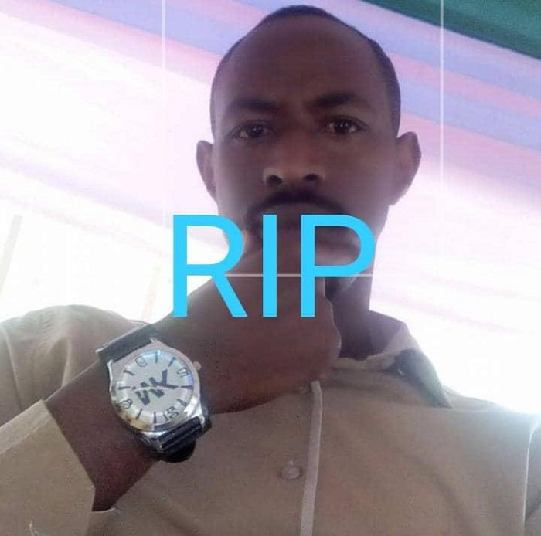
Twahirwa Laurent
Amakuru agera kuri Kigali Today aravuga ko inkuba yamukubitiye mu Mudugudu wa Winkaba, Akagari ka Buvungira, Umurenge wa Bushekeri mu Karere ka Nyamasheke ku wa Mbere tariki 05 Ukwakira 2020, akaba yari murumuna wa Kamali Aimé Fabien wahoze ayobora Akarere ka Nyamasheke.
Iyo nkuba ngo yabakubise ari abantu babiri muri uwo Mudugudu wa Winkaba, bajyanwa ku bitaro bya Bushenge, Twahirwa Laurent yitaba Imana ari kuri ibyo bitaro, naho undi yakubise witwa Ahishakiye Agnes w’imyaka 25 we abaganga bakaba bari bakomeje kumwitaho ku buryo ngo atanga icyizere cyo gukira.
TRANSLATION/SUMMARY FROM CITIZEN REPOPRTER FRANK SHUMBUSHO in RWANDA –
A brief translation of the Kinyarwanda reporting that I've just shared with you, is that "yesterday, 5 October lightning killed one Laurent Twahirwa, 40,while also injuring another woman who is now recovering at the hospital. This tragedy occurred in Winkaba Village, Buvungukira Cell, Bushekeri Sector of Nyamasheke District in the Western Province of Rwanda.

