Lightning strikes seven cows dead in Kasese
December 5th , 2022
https://www.independent.co.ug/lightning-strikes-seven-cows-dead-in-kasese/

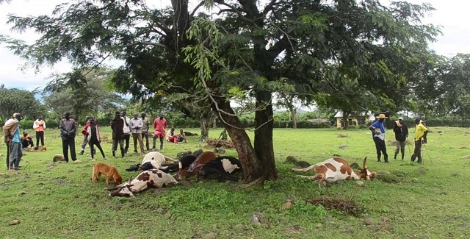Thunderbolt struck 7 cows dead. URN photo

Kasese, Uganda | THE INDEPENDENT | Lightning has struck dead seven cows belonging to Margret Kihita in Kabukero village, Karusandara sub-county, Kasese district. According to the residents, the thunderbolt struck on Sunday evening during a heavy downpour.
Kahita’s son, Bright Wamala, says that after milking he released the cows for grazing but a few minutes later, he received a phone call from a neighbor that the cows had been struck by lightning. He describes the loss as devastating since the family depended on daily milk sales for survival.
Eryeza Kabesere, the LCI chairperson of Kabukero East, and Richard Asiimwe, the chairperson of Kabukero farmer’s Cooperative society have called on the government through Operation Wealth Creation-OWC to support Kahita with free cows since she doesn’t have an alternative source of income.
They both described the incident as a mystery.

