11 Cattle Killed by Lightning in KZN
By Staff Writer 17-Oct-2019 23:56 UTC+02:00
https://www.publicnewshub.com/11-cattle-killed-by-lightning-in-kzn/
Eleven head of cattle belonging to one farmer were killed by lightning last week at Mboza in north-eastern KZN, Zulu newspaper Isolezwe reported on Thursday. According to the newspaper, the owner of the cattle, Mphishi Gumede, was so emotionally hurt by this unfortunate incident that he struggled to eat.
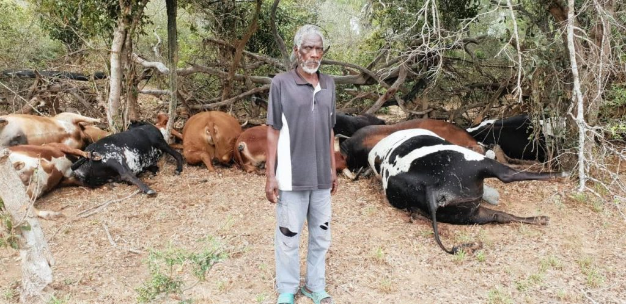
Mphishi Gumede is devastated after his cattle were killed by lightning. Image: Isolezwe.
Gumede said this calamity has left him heartbroken and unable to provide for his family as cattle farming was his only means of subsistence. “This has been inexplicably painful. I am very heartbroken. I relied on cattle to support my family as no one is working,” he said.
The matter has been reported to Jozini Municipality authorities, who promised to install lightning rods in the area and assist with burying the carcasses of the dead cattle. It is unclear if any other form of support will be provided to help Gumede resume cattle farming.
Last month two similar incidents occurred in distant parts of the world. In the first one, it is reported that 23 cows were struck dead by lightning at a farm in Annona, Texas, USA. In the second one, which occurred in Nigeria, lightning killed 36 cattle at Ijare sacred hill in the State of Ondo.
According to the National Lightning Safety Institute, South Africa is the third country with the highest number of lightning victims in the world (150 human deaths per year), and KZN has been described as a lightning magnet in the past due to its relatively high rate of lightning strikes. Earlier this year, KZN department of cooperative governance and traditional affairs announced a plan to roll out lightning conductors in vulnerable areas.

