**Channeling Lightning, Saving lives – Rwanda - United Nations**

**MARCH 17, 2022**

https://www.undp.org/rwanda/news/channeling-lightning-saving-lives

Rwandan Government data shows that from 2011 to 2018, storms have caused 244 deaths and destroyed or damaged 21,049 houses.

[Recent research](https://www.nytimes.com/2020/02/10/climate/lightning-africa-climate-change.html) has found that an increase in temperatures in Africa over the past seven decades corresponds with bigger and more frequent thunderstorms. In Rwanda, these storms often bring floods and landslides, and a barrage of lightning.

Government data shows that from 2011 to 2018, these storms have caused 244 deaths; destroyed or damaged 21,049 houses; affected 5,754 ha of crop lands; and damaged 248 classrooms.

UNDP Rwanda supports the Rwandan Ministry in charge of Emergency Management (MINEMA) and the Rwanda Meteorology Agency to reduce vulnerability to natural disasters such as extreme storms and to build climate resilience.

In the high-risk Rutsiro District, UNDP Rwanda financed MINEMA to install twenty-nine lightning protection systems (LPS) in twenty-three critical facilities. These grounding systems have benefitted over 1,000 households and eight schools.

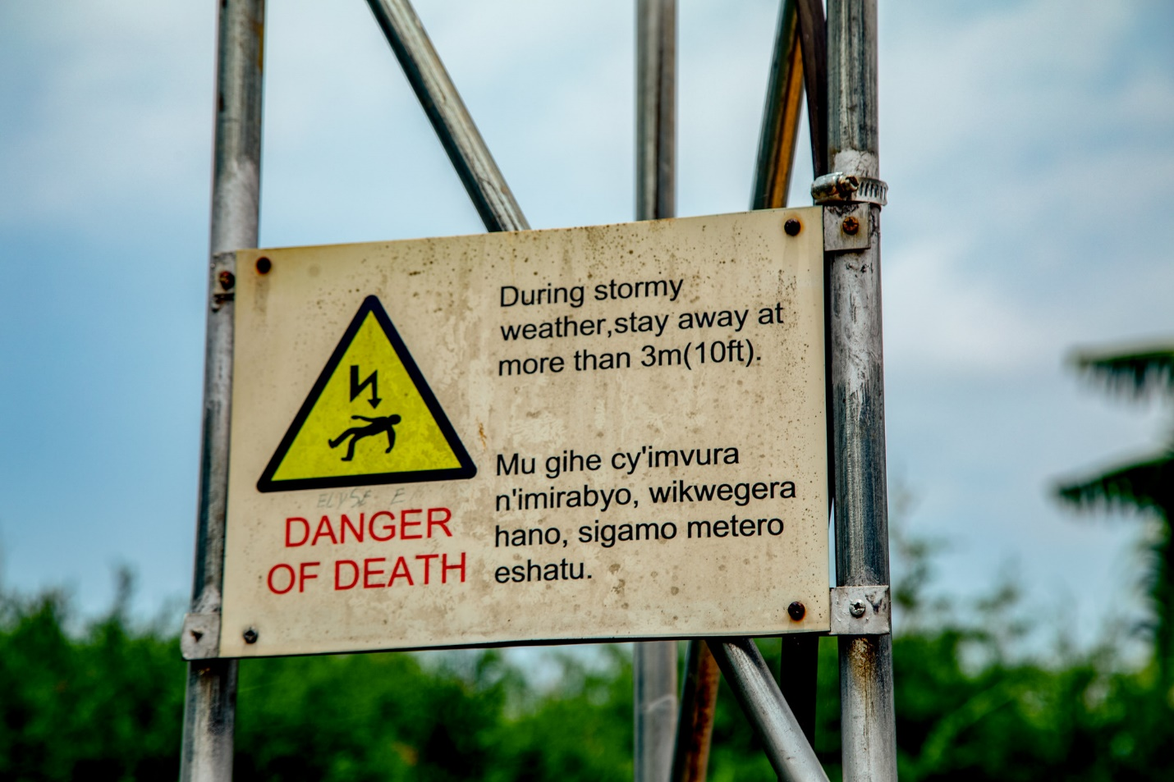

29 lightning protection systems (LPS) were installed in 23 critical facilities.

Outdoor protection systems intercept direct lightning via an air-termination system and channel and disperse the electric charges underground. Indoor systems protect electrical networks and equipment against power surges. In schools, students and staff are trained on system use and maintenance.

“Before we acquired 4 LPS, lightning strokes were a frequent and traumatic experience for the students,” says Murunda Secondary school Director, Father Johnson Abihirwe. “Children were frightened, and some had to be hospitalized for several days due to trauma.”

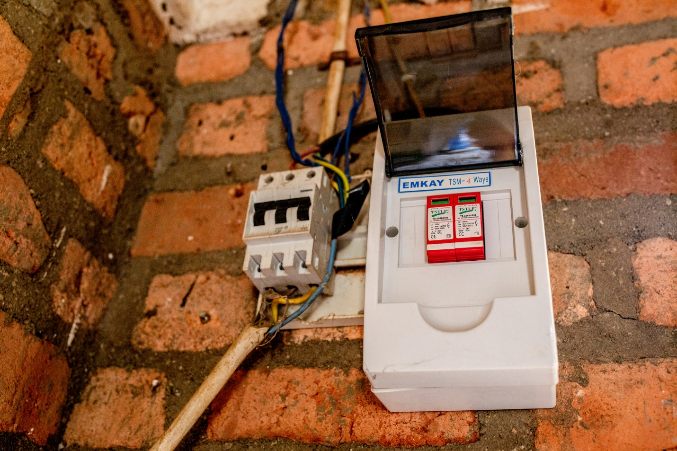

The former Mayor of the Rutsiro District, Ms. Emerence Ayinkamiye, commends UNDP initiatives in Karongi, where deaths from lightening strokes declined from 30 people in 2019 to 15 in 2020, and continue to protect the population today.