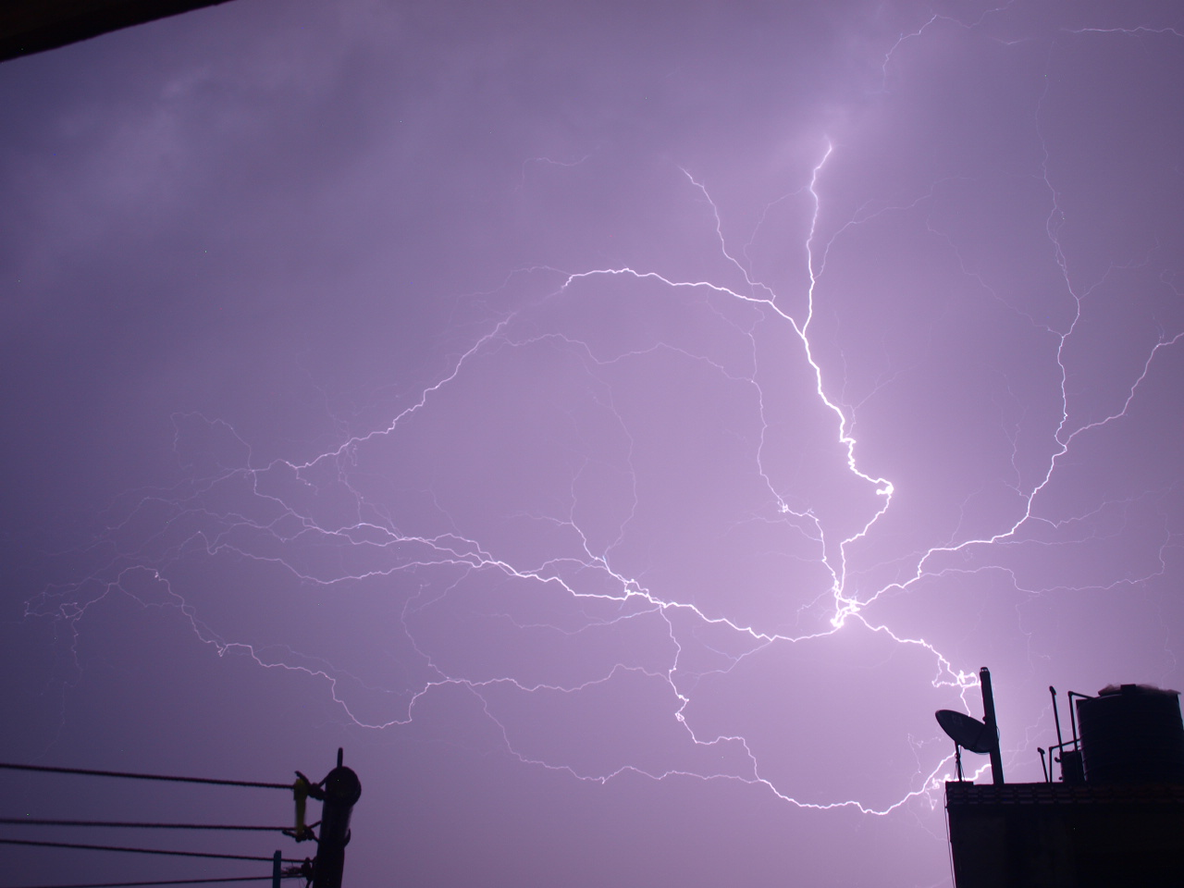
Two Day International Meeting on the Strategies of Promoting Lightning Safety and Protection Awareness
(Online Program)
(25-26 June, 2020)

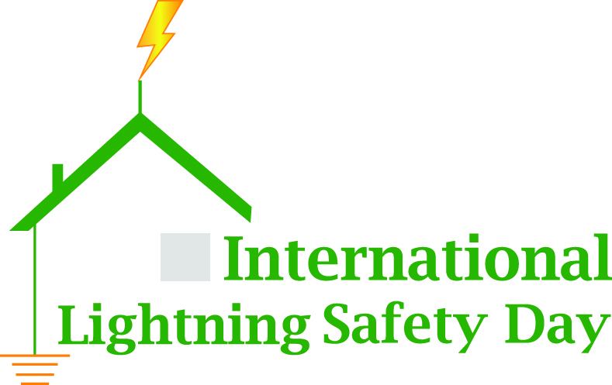

In preparation for marking

- Background
Due to the severity of the lightning and thunderstorm threat and lack of awareness in the rural communities around the globe and of the developing nations in particular, it has become the responsibility and challenge to the scientists, researchers, engineers, government authorities, humanitarian organizations to take initiatives to face the challenges. In order to address the issue South Asian Lightning Network (SALNet) wishes to organize a two-day’s Online Program on 25th and 26th of the June, 2020, targeting the marking of proposed International Lightning Safety Day (ILSD), on 28th of June 2020. The dates are so chosen that the lightning community can get prepared for marking the ILSD at their disposal.
This is the inaugural program for International Lightning Safety Day, 28th of June, which we hope to mark every year with prevention information for the media and the public. The meeting will be RECORDED and posted on YouTube Channel.

- Objective
With the main objective of mitigating the loss of lives and property due to lightning hazards, SALNet wishes to bring the leaders of lightning safety awareness from around the globe together with authorities of Disaster Management and humanitarian organizations for the promotion of awareness campaigns and mark International Lightning Safety Day that will further help raising awareness in the society.

- Agenda and schedule
Agenda | Speaker | Time (NST)
Progress and status of the national center- Bangladesh | Dr. Munir Ahmed, Bangladesh | 19:00-19:10
Progress and status of the national center- India | Dr. Anirban Guha,  India | 19:10-19:20
Progress and status of the national center - Nepal | Dr. Shriram Sharma,  Nepal | 19:20-19:30
Progress and status of the national center- Sri Lanka | Mrs. Janaki Athuraliya, /Mr. Nuwan Kumarasinghe  Sri Lanka | 19:30-19:40
On the strategies of raising awareness | Prof. Mary Ann Cooper, USA/Uganda | 19:40-19:50
Role of lightning detection systems for mitigating lightning hazards | Mr. Ronald Holle,  USA | 19:50-20:00
Affordable lightning nowcasting systems | Mr. Kumar Margasahayam, India/USA (did not attend) | 20:00-20:10
Role of industries in mitigating the hazards -Conducting trainings and awareness in the region | Mr. Gopa Kumar,  India | 20:10-20:20
What can we say about past lightning changes around the globe? | Prof. Collin Price,  Israel | 20:20-20:30
Challenges of establishment and sustenance of lightning centers | Mrs. Foster Lubasi,  Zambia | 20:30-20:40
ACLENet and its role in mitigating human loss | Mr. Richard Tushemereirwe, Uganda/Prof Mary Ann Cooper-ACLENet | 20:40-20:50
Way forward for the SALNet and other centers | Prof. Chandima Gomes,  South Africa | 20:50-21:00
Q&A Session | All speakers | 21:00-21:30
Day 2 (26th June 2020)
Introduction of participants and their role/association and need of the webinar | Dr. Shriram Sharma (SALNet, LARC) | 19:00-19:15
On the objective of SALNet and other centres | Prof. Chandima Gomes | 19:15-19:30
A fascinating Journey with Lightning from the ashes of Richmann to the chimerical dream of multi=hazard rick resilience | Prof. R.K. Bhandari, India | 19:30-19:45
Impact of Awareness - an experience from USA | Prof. Mary Ann Cooper | 19:45-20:00
Present scenario of lightning fatalities and threat | Mr. Ronald Holle | 20:00-20:15
Significance of training Engineers in the developing world | Mr. Gopa Kumar | 20:15-20:30
Involvement of ADPC in PAL training an experience from Nepal | Mr. Man Thapa,  Thailand | 20:30-20:45
What do climate models predict for the future of  thunderstorms around the globe? | Prof. Collin Price | 20:45-21:00
India's Technological readiness for lightning Risk Reduction | Dr. Debapriya Dutta  India
Status of awareness and role of National Disaster Risk Reduction and Management Authority (Nepal) | Mr. Anil Pokhrel, Chief Executive, NDRRMA, Nepal
Q&A Session | All Speakers | 30 Minutes
Concluding Remarks | Dr Shriram Sharma | 5 minutes

Organized by
