Lightning kills one in Mchinji | Malawi
https://malawi24.com/2017/11/14/lightning-kills-one-mchinji/
By Bright Malenga
Nov 14, 2017
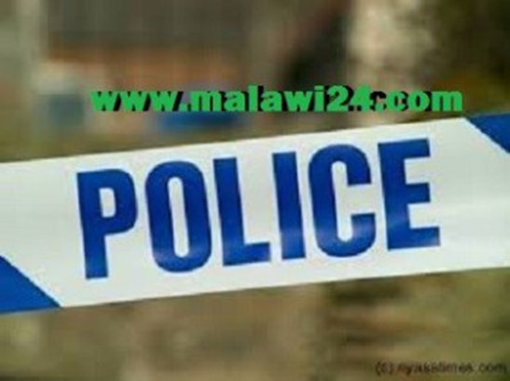
The rainy season is here and with it are the casualties.
A 33-year-old man in Mchinji has died after being struck by lightning.
According to a brother of the deceased, the man Innocent Nthere was electrocuted by lightning that struck him in the evening hours of November 11, 2017 within Mchinji Boma.
Malawi24 caught up with Mchinji police spokesperson Kaitano Lubrino who confirmed about the death.
Lubrino told Malawi24 that Nthere was cycling from his maize garden towards his home and at the time there was a thunderstorm.
Lightning then struck the man and he died on the spot.
A postmortem conducted at Mchinji District Hospital established that death occurred due to electrocution.
Meanwhile, the police through Mchinji Police Station are advising the general public to make sure that they adhere to weather forecast guidelines to avoid re-occurrence of similar incidents.

