Girl Killed and Eight Injured by Lightning in Storm [Malawi]

21 November 2021

An eight - year old girl was struck to death and another eight were injured by lightning that was accompanied by strong winds that blew off roofs of 32 houses. This incident occurred in Chief Kanyenda's in Mkhota Kota District, Central Region on Sundsy, 21st November, 2021.
The incident has been reported by Mr. Charles Banda, a ward Councilor for the affected area.
This is the first lightning incident in the current 2021 - 2022 rainy season.

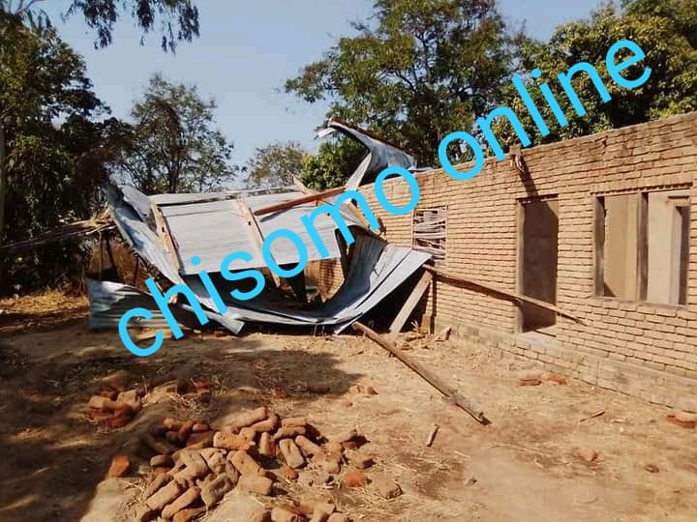

By email from Gilbert Phiri in Malawi at enkupeniconglomerate@gmail.com.

