**LIGHTNING INCIDENCE AT KAMDINI TOWN COUNCIL IN OYAM DISTRICT**

The incidence happened on August 25th, 2020 around 2pm East African Time at Boroboro “A” village, Pukica parish, Kamdini sub-county Oyam district. There was slight clouding in the sky during that time when the children were playing in the compound in a group of five children.

PERSONAL DATA of LONE VICTIM

**Name of the deceased:** Obangakene Innocent

**Age:** 6yrs

**Mothers name:** Nam Jane

**Fathers’ name:** Abila Patrick

**Village:** Boroboro “A”

**Parish:** Pukica

**Sub-county:** Kamdini

**District:** oyam District

One dead, four injured

According to one of the child survivors, she could only remember seeing a bright light and afterwards they were all lying on the ground.

When she gained consciousness, she realized that one of them was thrown away, some 15 meters under a certain tree, but he was already dead by the time rescuers came.

According to the mother of the deceased, there were physical injuries on him, his hair was burnt, his back was burnt too and the waist. His shirt was also burnt from the back.

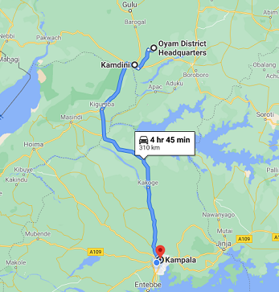

*Fig. 1: Map showing Kamdini where lightning killed one child*

GPS coordinates of the Location. 2.297287, 32.371525

The four survivors had no burns, they were just thrown on the ground unconscious.

The tree that the boy was thrown under was also struck and dried up, unfortunately the parents of the deceased had to uproot the tree off because it bring back bad memories.