Kuresoi lightning strike leaves 3 pupils dead, 53 admitted [Kenya]

THURSDAY JANUARY 16 2020

https://www.nation.co.ke/counties/nakuru/Lightning-kills-3-pupils-in-Kuresoi/1183314-5420846-xa1o17/

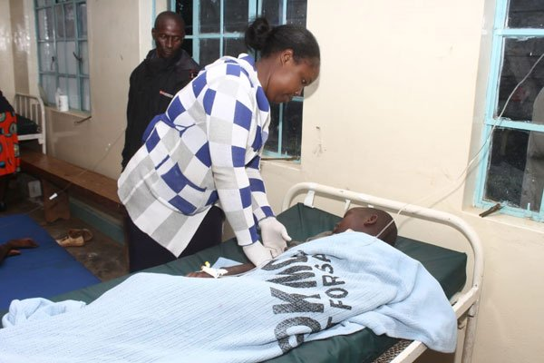
A pupil is treated at Kuresoi Health Centre on January 16, 2020, for injuries sustained after lightning struck classrooms at Mkulima Primary School in Kuresoi North Sub-county, Nakuru County.

In Summary
- The Grade Four and Five learners were in their classes when the incident took place at around 3pm.
- Mkulima Location Chief John Macharia Muhia said he received information about the tragedy from a Nyumba Kumi elder.
- He urged the government to install lightning arresters in schools to prevent similar cases.
- Nakuru Governor Lee Kinyanjui said that the county had dispatched three ambulances to transfer four critically injured pupils to Nakuru Level Five Hospital.

