LIGHTNING KILLS BULAWAYO SCHOOL GIRL (Zimbabwe)
http://www.chronicle.co.zw/lightning-kills-byo-schoolgirl/
Published On February 05, 2015
By Oswell Moyo and Marvelous Moyo
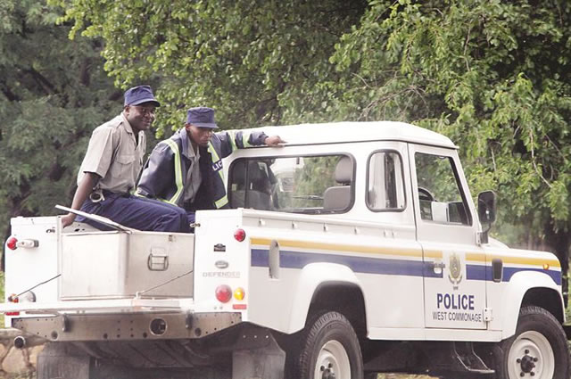
In the CHRONICLE BULAWAYO – A grade 6 pupil died yesterday after being struck by lightning while walking to a dustbin within the school grounds.
Members of the Zimbabwe Republic Police leave Gampu Primary School with the body of the child who was struck by lightning at the school premises in Bulawayo yesterday (Picture by Obey Sibanda)
Tragic Sandra Netsanza, 11, who had just helped clean up a classroom at Gampu Primary School in Bulawayo’s Mpopoma suburb, was carrying a dust pan heading to a waste bin with classmates when lightning struck at around 1PM, witnesses said.
A teacher, who was among the first people to find young Sandra’s body, told The Chronicle: “It was around 1PM after the lunch bell had rung. Sandra and her classmates had been sweeping their class and they were going to dispose of the rubbish.
“It was drizzling at the time after heavy rains earlier. Suddenly, we were jolted by screams and we rushed to find Sandra already dead, apparently struck by lightning. Her mates that she was walking with were spared though.
“It was slightly strange really, because there is a tall tree just metres from where she fell. Were we not taught that lightning strikes the tallest object? It’s sad really, many thought it was African science (witchcraft).”
When our news crew arrived at the school shortly after 4PM, Sandra’s distraught schoolmates were struggling to comprehend what had just happened, dozens of parents rushed to the school to pick up their children.
Her relatives, who are members of a church sect known as Vapostori, had also arrived.
Emotions ran high as they manhandled a news crew from another newspaper and threatened our photographer.
Dressed in their white gowns, they also threatened witnesses from talking to journalists.
Police took more than three hours to arrive at the school, finally removing Sandra’s body from the scene after 5PM. By then, a large crowd had gathered.
Her body was placed in a silver metallic coffin which was loaded onto the back of an open-top police truck.
On Monday, six children and an adult were killed when lightning struck two huts in Mugwinyi Village in Bikita.
The dead have been identified as Marian Nebvuma, 32, Fadzai Chenjerai, 11, Gloria Chenjerai, 5, Odrey Masunda, 4, Esther Muchakagara, 5, Claudia Mugwinyi, 4 and Crywind Mugwinyi, 6.
Meanwhile, a Grade 6 pupil at Marvel Primary School pupil in Filabusi collapsed during an athletics practise session and later died after efforts to revive her failed.
The 12-year-old girl, identified as Mercy Chizema, collapsed in the school’s sports field on Monday at around 2.30PM.
A teacher said: “After running for a distance of about 400m, she fell to the ground. The training teacher attended to her and later called other teachers to the scene.
“Everyone thought she had fainted. Efforts were made to resuscitate her but to no avail. She was quickly rushed to Filabusi District Hospital where she was pronounced dead on arrival,” said the source.
Matabeleland South provincial police spokesperson Inspector Philisani Ndebele said: “We received a report of a female juvenile who collapsed at the school grounds and was certified dead upon arrival at the hospital. No foul play is suspected.” The Chronicle

