**Anambra school holds post-trauma session for pupils over lightning incident [Nigeria]**

14th November 2023

By [Ikenna Obianeri](https://punchng.com/author/o-ikennapunchng-com)

<https://punchng.com/anambra-school-holds-post-trauma-session-for-pupils-over-lightning-incident/>

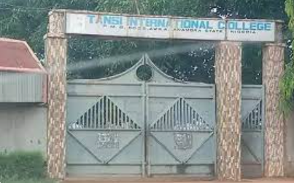

Tansi International College

A school in Anambra State, Tansi International College, Awka, has held a post-trauma session for its pupils, to ease their minds off the lightning incident that killed three pupils of the school recently.

Some weeks ago, nine pupils of the school were reportedly struck by lightning while playing football on the school pitch during rainfall and were rushed to the hospital where three of them were confirmed dead.

The state governor, Chukwuma Soludo, had in the aftermath of the incident also consoled the management and students of the school and the relatives of the deceased students.

The Principal of the College, Fidelis Izuakor, who spoke during the post-trauma session on Tuesday, said the essence of the “psychosocial intervention” was to rehabilitate the students from shock and trauma resulting from the incident.

Izuakor said, “We believe, as humans that the shock or the sight of the incident could cause one form of trauma or the other on the students because they were all there when it happened.

“We are not sure, and cannot detect any of them with trauma. So we decided to invite counselors to help us talk to them, counsel them, take them along that particular place of trauma, bringing them out of it. That is the essence of this counseling session.”

The session was conducted by three reverend sisters from the Immaculate Heart of Mary, Mother of Christ, Amawbia Community.  
The counsellors included; Reverend Sister Bibian Marie Okelue, Reverend Sister Raphaela Maria Nnorom, and Reverend Sister Maria Echezonachukwu Dim.

Dim while addressing the pupils, said the effect of the incident, if not handled properly now, might have negative impacts on the lives of the students in the future.

She said, “The lives of the deceased pupils have a spot in every one of you as a part of a bigger family here. Today, they have gone. This has created a negative vacuum in you.

“You may not know that if you don’t handle well what happened to you that Saturday, in 30 years, it may cause something you may not know.

“I know all of you know the deceased. So, the major reason we are here is to help you handle the fear and your thoughts about them in the best and most positive way.”