Lightning fatalities in Rwanda church were avoidable

SUNDAY MARCH 18 2018

By IVAN R. MUGISHA

http://www.theeastafrican.co.ke/rwanda/news/lightning-fatalities-in-rwanda-church-were-avoidable/1433218-4345028-6jfddq/index.html

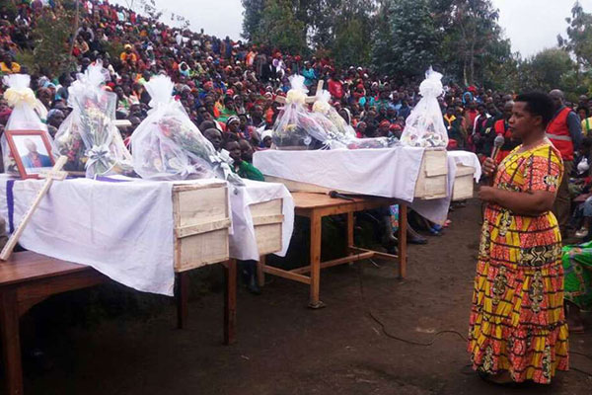
Governor of Southern Province Marie Rose Mureshyankwano speaks at a funeral service for the 16 victims who died after their church was struck by lightning on March 10, 2018. PHOTO | CYRIL NDEGEYA | NATION

In Summary
- The Rwandan church in which 16 people were killed by a lightning strike was scheduled to be shut down because it lacked basic security features.
- Lightning struck the Seventh Day Adventist Church on March 10, instantly killing 14 people, while two people later died after succumbing to their injuries.
- Authorities say that many churches in Nyaruguru do not have lightning conductors, while most homes also find them too expensive to install.
The Rwandan church in which 16 people were killed by a lightning strike was scheduled to be shut down because it lacked basic security features, government officials say.

However, the directive to shut it down was not implemented in time, which jeopardised the lives of over 150 worshipers who were inside the church when the lightning struck.

“The decision had been taken to close it, but it was not easy to implement it. There are over 200 churches operating in Nyaruguru District and each one was under review,” Mayor of Nyaruguru District, Francois Habitegeko told Rwanda Today.

The Ministry of Disaster Preparedness and Refugee Affairs also uses mobile phone SMS services to alert and warn the public of imminent weather and natural disasters, but this was not done.

Weather forecasts by the Meteorology Agency failed to predict strong lightning or issue a warning urging people in the district to protect themselves against possible lightning strikes.

The church is located in Nyaruguru District, where some other 55 churches were closed by authorities because of noise pollution, poor hygiene and they lacked basic security features such as lightning conductors.

Lightning struck the Seventh Day Adventist Church on March 10, instantly killing 14 people, while two people later died after succumbing to their injuries.

Over 140 people were also injured and rushed to hospitals and health centres, but only three were still in critical condition.

The previous day, a student was killed after being struck by lightning in the same district.

Authorities say that many churches in Nyaruguru do not have lightning conductors, while most homes also find them too expensive to install.
“Lightning equipment is expensive, but this does not mean that people cannot be protected from lightning,” Mayor Habitegeko said.
Lightning killed 30 people across the country in 2016, according to Rwanda’s Ministry of Disaster Management and Refugee Affairs.
Last year’s statistics were not readily available, but in October, 18 people died after being struck by lightning.
Whereas traditional and religious beliefs consider lightning to be a divine act, the government has endeavoured to minimise the damage caused by lightning and adverse weather condition by beefing up the Meteorology Agency.
In October last year, the agency installed four new automatic weather stations to expand its observation network and provide more accurate weather information that is also disseminated faster.
However, it failed to predict the lightning catastrophe in its five-day weather forecast for March 8 to March 12 and its website has nothing recorded in its “latest warnings” section.
“We send out four weather updates every day to inform people of likely weather changes.
The challenge we now have is on disseminating the alerts,” said Anthony Twahirwa, division manager of Weather and Climate Services and Application at the Rwanda Meteorology Agency.
“Most radio stations ask for payment to disseminate the weather information, so we decided to create WhatsApp groups for every district to share the information as soon as possible and warn people,” he added.
The agency now plans to install 20 more weather stations in partnership with the Ministry of Agriculture, which will increase the number of weather stations to 328.

Related Content
- 'Lightning strike' causes fire at Rwandan hotel
- 16 killed as lightning strikes Rwanda church
- Rwanda shuts 700 unsafe, noisy churches

