Lightning kills three children in Bundibugyo - UGANDA
Friday, November 12, 2021
https://www.monitor.co.ug/uganda/news/national/lightning-kills-three-children-in-bundibugyo-3616408?fbclid=IwAR3QzUC1MUQUSl5bM68BSCnVm0BC2zuPWgDZ6fg-gvLnDcqnVHegEGQpWs4
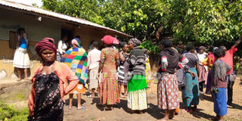
Residents gathered at the family of the deceased children in Bundibugyo District on November 11. PHOTO/LONGINO MUHINDO
By Longino Muhindo
Three children died Thursday and four others were seriously injured after being struck by lightning in Kirumya Sub-County, Bundibugyo District.
The incident happened in the evening in Kasodo Village, during downpour that lasted close to four hours.
The deceased have been identified as Patience Biira,10, Joan Kabugo, 8, and Joas Bwambale,4.
One of the survivors, Sarah Mbambu, said they were in a group of 10 children cooking palm oil on the river side at the time thunder struck.
Katumba police post Officer in Charge (OC), Mr Steven Atwemereho told Daily Monitor that ‘‘bodies of the deceased have been handed over to the relatives for burial.’’
The Chairperson Kasodo Village, Mr Yofesi Baluku said the injured are now receiving treatment in a nearby health facility.
The Kirumya Sub-county chairperson, Mr Abraham Bamwitirebye advised community members to always be careful about lightning in rainy seasons.

