Ronald L. Holle
International lightning expert on the demographics of lightning injury
ACLENet Executive Committee and Board of Directors
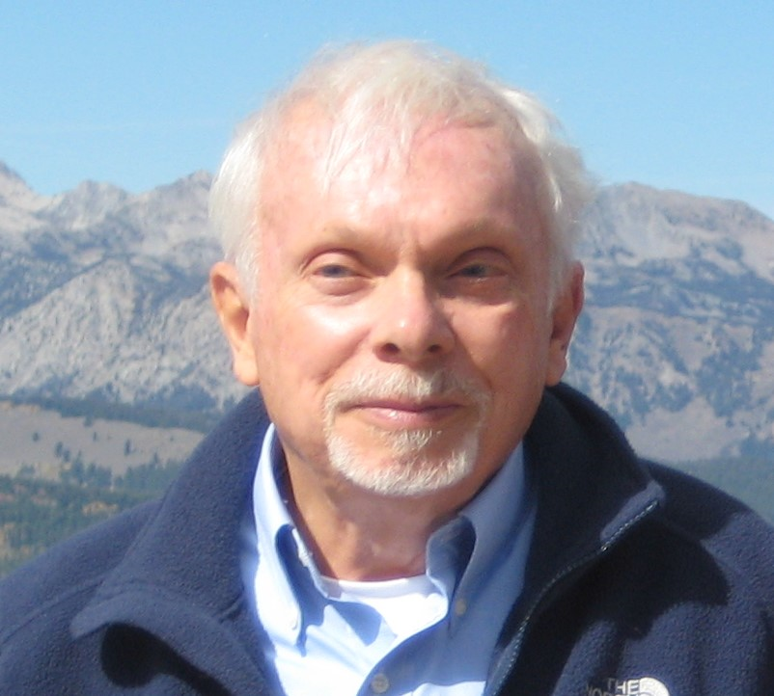
HERO OF THE MONTH - 2023-05

- What is your background?
I am a meteorologist who has studied nearly all types of weather phenomena, especially convection. These studies have involved thunderstorms and their attendant lightning, as well as microbursts, flooding rain, heavy snow, hurricanes, and tornadoes. Since the late 1970s, I have worked extensively with lightning data from ground-based sensors developed here in Tucson, Arizona, and published climatologies of lightning in countries and regions around the world, as well as individual thunderstorms and thunderstorm types. I recently co-authored a book that includes the history of the development of real-time lightning detection in Arizona with Dr. Daile Zhang, another member of the ACLENet Board of Directors.

- How and when did you hear about ACLENet?
I have been studying lightning deaths and injuries for many years, and the multiple-casualty events in Africa came to my attention through Dr. Mary Ann Cooper. I had already been working with her since the 1990s, then we helped form the Lightning Safety Awareness team of the NOAA/National Weather Service in 2000.

- What motivated you to work with ACLENet?
Why do these multiple-casualty events happen in Africa and other developing countries? How often do they happen, and what can be done to reduce them?

- Please describe your work with ACLENet.
I have studied African lightning events, especially in Uganda. I have monitored lightning death and injury events around the world, and helped developed a database of them in African countries. I have participated in weekly meetings of the Executive Committee and monthly meetings of the Board of Directors of ACLENet for several years.

- What are some of your key achievements so far with ACLENet?
Conference posters and papers have been written and widely distributed for several meetings in the U.S, Africa, and Europe during the last decade. Recognition of the magnitude of the problem of lightning at schools has spread through parts of the Uganda educational system. Recommendations have been given during Executive Committee and Board of Directors meetings. When possible, I also like to complement the death and injury studies with lightning data from the NLDN or GLD360 networks.

- What are some of the challenges you have encountered in your work with ACLENet? How have you addressed these challenges?
Inertia and a nearly complete lack of understanding of lightning within Uganda at many levels and agencies is difficult to overcome, so long-term persistence is needed. Funding is a massive challenge to all activities of ACLENet and breakthroughs in adequate money are few and far between.

- How would you like to see ACLENet develop in the future?
Spread information about lightning through all levels of schools, education, and media as much as possible in Uganda. Be sure that all new schools are properly protected from lightning. Once established, Uganda can then become an example of lightning safety and protection knowledge for other countries in Africa.

- What do you see in the future for ACLENet regarding lightning safety?
ACLENet needs to enable every new Uganda school to be properly protected from lightning, and the students and staff need to know what to do when lightning is a threat. Also, to the extent possible, retrofit all schools with correct lightning protection. These examples can then extend to all parts of society. Subsequently, this Uganda model can be extended to other countries in Africa.

- Encouragement note.
Uganda lightning safety efforts are essentially the only projects being made in Africa, except in South Africa. ACLENet is the only lightning safety organization in the world that has actually provided lightning protection for school buildings. While often frustrating, these projects are prototypes and are hopefully recognized as a first step in lightning safety and protection in the future.

- Is there anything else you would like to include – personal information, family, goals, etc? Is it ok to list your email?
I am also involved in lightning safety efforts in Bangladesh, Nepal, Mexico, and other countries in Africa where the situation of a developing country is the same as in Uganda, namely inadequate buildings such as schools and labor-intensive agriculture. However, the scenario for how to address the issue varies from Uganda.

Your answers to these questions will be posted on ACLENet’s website at:
https://aclenet.org/news-publications/newsletters/hero-of-the-month-column.html

THANK YOU for all you do for ACLENet and for saving lives - MA

