HERO of the MONTH
March 2024

Katie Flanagan
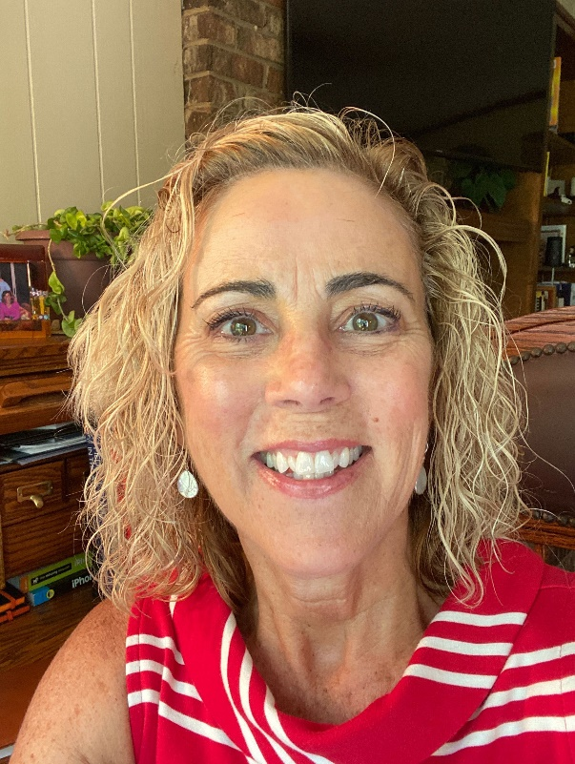

- What is your background?
I am a professor and the Director of Sports Medicine at East Carolina University, where I have been since 1995. My area of research has been environmental safety related to sports, and I have co-authored national (US) position papers in lightning, heat illness and sudden death in sports.

- How and when did you hear about ACLENet?
I was fortunate enough to be connected to Dr. Mary Ann Cooper shortly after arriving at East Carolina University, when beginning my research on lightning safety in athletics and recreation. She has kept me abreast of the wonderful positive impact ACLENet has had in Africa over the years.

- What motivated you to work with ACLENet?
When Dr. Cooper called and asked me to assist with the leadership and organization as ACLENet faced prospective changes in board functioning and management, I was happy to provide my experiences from working with other national boards in the US. More importantly, I was eager to work with such a passionate and diverse population, who have collective focus on lightning safety in African schools.

- Please describe your work with ACLENet.
I assisted as a Board member and worked to bring a more formal Board structure as it related to other US National Boards where I served.

- What are some of your key achievements so far with ACLENet?
My achievements in ACLENet are unremarkable but for the wonderful relationships I have made with a phenomenal group of dedicated individuals.

- What are some of the challenges you have encountered in your work with ACLENet? How have you addressed these challenges.
I see ‘challenges’ as ‘opportunities.’ Some of the opportunities ACLENet has are to branch outside current mindset for other funding sources, to diversify the Board to include business-minded individuals, and those with extensive work in non-profits. Other opportunities are to spread the work of the Board out so one person/few people are not carrying the entire workload (finance, seeking funds, on-the-ground management, website, communications, etc.).

- How would you like to see ACLENet develop in the future?
There are prospects for funding if ACLENet can see outside of traditional avenues already investigated. I encourage those associated with ACLENet to reach out and inspire others to assist ACLENet to become even bigger and invite/bring other unique skill sets to the group to increase revenue, opportunities, communications and knowledge.

- What do you see in the future for ACLENet regarding lightning safety?
I vision ACLENet as an international model for successful lightning safety in underrepresented areas. Once fully funded and diversified, this Board can be an international leader in providing much-needed safety services in international rural areas.

- Encouragement note
ACLENet has the passion, knowledge and drive to succeed in the future! The people encompassing ACLENet are all phenomenal humans with a common drive to protect others from the dangers of lightning, and far better, providing education to keep others safe. There needs to be a sustained funding source, as well as broader base of individuals to assist with this wonderful work.

- Is there anything else you would like to include – personal information, family, goals, etc? Is it ok to list your email?
I am so very proud to be affiliated with environmental safety and getting the messages out to all people on how they can do better.

Please DO provide my email – Flanagank@ecu.edu

