**Collapsed wall and lightning strike, leaves multiple dead - Rwanda**

[**https://rwandadispatch.com/collapsed-wall-and-lightning-strike-leaves-multiple-dead/**](https://rwandadispatch.com/collapsed-wall-and-lightning-strike-leaves-multiple-dead/)

[16 February 2024](https://rwandadispatch.com/collapsed-wall-and-lightning-strike-leaves-multiple-dead/)

[[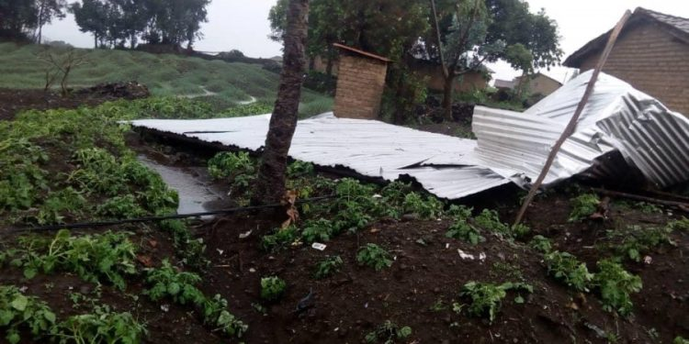](https://rwandadispatch.com/wp-content/uploads/2023/07/Rainfall_Rubavu.jpg)](https://rwandadispatch.com/wp-content/uploads/2023/07/Rainfall_Rubavu.jpg)

[Unusually intense seasonal rains have unleashed floods that have affected local residents and submerged farmland in several parts from North and Western Rwanda in May this year](https://rwandadispatch.com/wp-content/uploads/2023/07/Rainfall_Rubavu.jpg)

In Gatsata one of Kigali’s suburbs, heavy rains on Thursday, February 15th, resulted in two separate tragedies that claimed the lives of six people and injured several others.

According to reports, a stone wall collapsed on a house in Gatsata Sector, Gasabo District, killing a father and his one-year-old child. The wife and his child were critically injured and rushed to CHUK Hospital for treatment.

National Police spokesperson ACP Boniface Rutikanga confirmed the incident, stating the family was residing below the wall when it gave way.

Four people were struck and killed by lightning while praying in Mbirima Cell, Coko Sector, Gakenke District. The incident occurred in the North Province.

Additionally, heavy rains caused a mudslide that closed the Rugunga-Kanogo road, disrupting traffic flow. Flooding was reported in other areas, including roads leading from Gikondo to Mukanogo and Lyce School to Kanogo.

Emergency services responded to both incidents, providing medical attention to the injured and recovering the bodies of the deceased. Meanwhile, Investigations are underway to determine the full details of the tragedies.

These tragic events highlight the potential dangers of severe weather in Rwanda. Residents are urged to take precautions during heavy rains and thunderstorms, including seeking shelter in sturdy buildings and avoiding open areas.

Adding to the somber mood, Meteo Rwanda’s recent forecast warns of potentially severe weather conditions for the rest of the month.

Rainfall is expected to exceed normal levels nationwide, with the southwest region bracing for the heaviest downpours of 130-160 mm. This raises concerns about floods, mudslides, and landslides, particularly in low-lying areas.