Lightning kills three in Gakenke, Nyagatare (Rwanda)

By  [Kelly Rwamapera](http://www.newtimes.co.rw/node/861397), June 06, 2018 | Updated : June 06, 2018

http://www.newtimes.co.rw/news/lightning-kills-three-gakenke-nyagatare

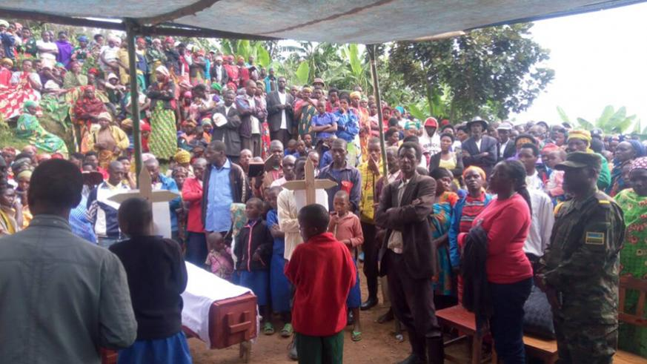

Residents and local authorities at the burrial of lightning victims on Wed at Ruhinga Kivuruga Sector in Gakenke District. Kelly Rwamapera

Lightning struck four relatives on Tuesday evening, instantly killing two of them, including a 12-year-old girl in Kivuruga Sector, Gakenke District.

The other two are currently admitted at Nemba Hospital in the same district.

Another victim of lightning that characterized evening rains on Tuesday is a 48 year old man who was struck as he worked in a rice plantation in Nyagatare Sector, Nyagatare District. He also died instantly.

Speaking to *The New Times*, Dr. Jean-Baptiste Habimana from Nemba Hospital said that the two who were admitted at his hospital were recovering well and likely to be discharged later on Wednesday.

The Executive Secretary of Kivuruga Sector, Jean-Bosco Nkurunziza, said the deceased; Denis Biziyaremye 25 and Clarisse Uwera 12 were collecting cattle grass in the drizzles.

Nkurunziza says this is not the first time lightning struck in this area, adding that they would meet with residents to sensitise people on how best to protect themselves.

“The area is prone to lightning because much of it is on high altitude,” he said.

The same rains caused mudslides on Rubavu Hill in Rubavu District, destroying hundreds of trees on the hill and at least four houses. No one was injured, according to local authorities.

**Disaster response**

The Director of Risk Reduction and Preparedness Unit at the Ministry of Disaster Management and Refugee Jean Baptiste Nsengiyumva says the ministry is still sensitising the masses on prevention of lightning including lighting rods on public facilities.

“We cannot stop the lightning phenomenon but we can mitigate its impact by staying indoors during rain and installing lightning rods,” he said.

He said that the ministry has installed lightning preventers in the prone areas of Rutsiro District in Western Province.

“We have installed one at Rutsiro District offices and another at College de la Paix. We’ll have to install more in various areas” he promised.

Nsengiyumva also warned the public of substandard lightning rods on the market that cost cheaply.

“We cannot recommend any dealer but we know of cheap lightning rods that go for as little as Rwf15,000 which cannot save a life,” he said.

Since January this year, the lightning has killed over 50 people including 15 Seventh-day Adventists who were killed at once in a church in Nyaruguru District Southern Province.

[***editorial@newtimes.co.rw***](mailto:editorial@newtimes.co.rw)