**Malawi witchcraft murders: Angry mob torches seven people to death**

*By* [*Romil Patel*](https://www.ibtimes.co.uk/reporters/romil-patel) *March 2, 2016 12:09 GMT*

*https://www.ibtimes.co.uk/malawi-witchcraft-murders-angry-mob-torches-seven-people-death-1547084*

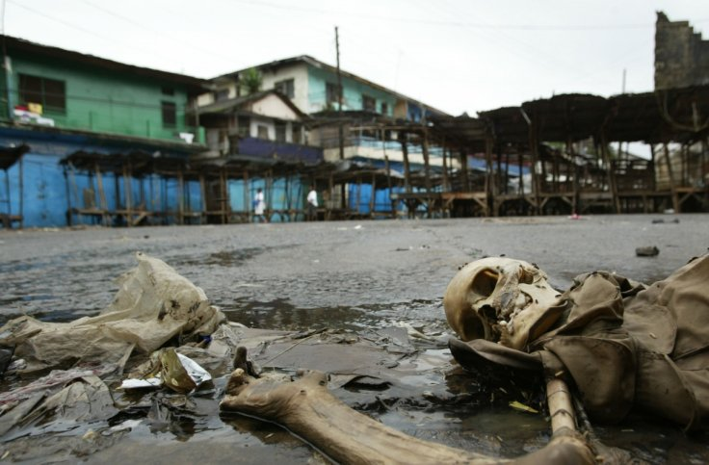

Seven people were burned to death after being accused of witchcraft by an angry mob Chris Hondros/Getty

Seven people have been torched to death in Malawi following allegations that they held human bones for use in witchcraft rituals, police have said. The incident occurred in the country's southernmost district, Nsanje, on Tuesday 1 March.

Police have launched an investigation into the matter, according to [Malawi's Capital FM.](http://www.capitalradiomalawi.com/news/item/5863-malawi-police-launch-investigations-into-nsanje-killings) The people were "found in possession of human bones and the mob took it upon themselves to burn them with petrol," the officer in charge, Kirby Kaunga told the local media. "We have not yet made any arrests. We are currently investigating the matter," he added.

The movements and phone conversations of one of those killed aroused suspicion in the local community and he was eventually caught with a bag containing the bones, a traditional chief said. "He was chased and arrested," chief Tengani – who goes by one name – [told AFP.](http://news.yahoo.com/malawi-mob-burns-7-death-over-suspected-witchcraft-091957287.html) "The man is said to have confirmed that his bag contained human bones and that's when the mob began rounding up the seven and burned them one by one," Tengani added.

The latest killings come just four weeks after four elderly people were murdered in Malawi's southern Neno district in broad daylight after they were alleged to [have practised witchcraft.](https://www.ibtimes.co.uk/south-africa-teacher-benedict-daswa-beatified-after-being-killed-opposing-witchcraft-1519631) The mob accused the elderly victims of using lightning to kill a 17-year-old girl, according to reports.

The senseless murders prompted Malawi's President, Peter Mutharika to condemn the acts of violence. "The president is saddened by the brutal acts of the mob in Chimbalanga Village and has since ordered the Inspector General of the Malawi Police Services to investigate the matter and bring to justice and trial of all those involved in killing the four innocent people," said [presidential spokesperson, Gerald Viola.](http://www.chronicle.co.zw/mutharika-shocked-at-brutal-murder-of-4-elderly-people/)

The girl was struck by lightning on 26 January as she arranged buckets to collect rainwater. Following the event, an angry mob mobilised themselves before going on a bloody rampage and beating the elderly citizens to death. Viola appealed to Malawians "to stop accusing the elderly of witchcraft whenever someone dies."

Responding to the attacks, the Malawi Civil Society condemned the attacks and said: "Mob justice violence, whatever the reasons behind it, finds no justification in both our domestic and international legal human rights system as it violates the right to due process, sanctity of life and their presumptive innocence until proven otherwise by a competent court of law."

More about witchcraft

* [Uganda Elections 2016: Children decapitated in 'good luck sacrifices' as Yoweri Museveni wins](https://www.ibtimes.co.uk/uganda-elections-2016-children-decapitated-good-luck-sacrifices-yoweri-museveni-wins-1546666)
* [Witchcraft: Man arrested for family killings connected with blue moon](https://www.ibtimes.co.uk/witchcraft-man-arrested-family-killings-connected-blue-moon-1526012)
* [Papua New Guinea: 'Witches' stripped naked and tortured in horrific video [Graphic content]](https://www.ibtimes.co.uk/papua-new-guinea-witches-stripped-naked-tortured-horrific-video-1525394)
* ['Witchcraft' and 'exorcism' child abuse cases on the rise in the UK](https://www.ibtimes.co.uk/witchcraft-exorcism-child-abuse-cases-rise-uk-1523454)