
Sixteen pupils hospitalised after lightning strike (Uganda)
By Robert Atuhairwe
Added 30th September 2017 05:28 PM
https://www.newvision.co.ug/new_vision/news/1462728/sixteen-pupils-hospitalised-lightning-strike
No lives were lost in the incident that happened when the pupils were in class at about 11:00am on Friday.
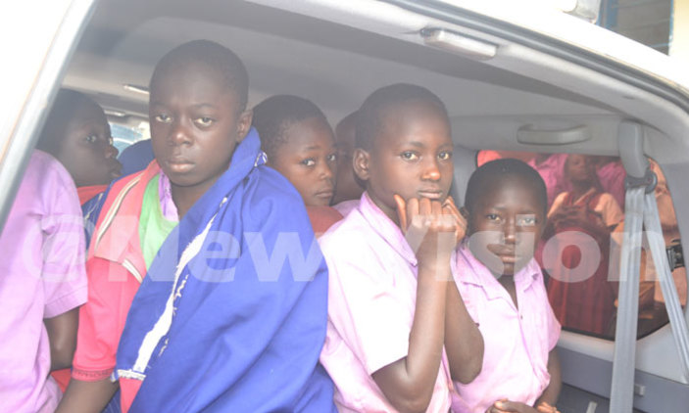
PIC: Pupils of Kifumura Primary School in Buhanika Sub-County, Hoima district, being taken to hospital. (Credit: Robert Atuhairwe)
Sixteen Pupils and a teacher of Kifumura Primary School in Buhanika Sub-County, Hoima district remain hospitalized at Hoima Hospital after they were struck by lightning during a heavy downpour on Friday.
No lives were lost in the incident that happened when the pupils were in class at about 11:00am.
The school headteacher, Jackson Tibetegya, told New Vision that most pupils collapsed after the incident.
Steven Mugisa, a teacher who was at the time conducting lessons in a P4 class, said one of the windows collapsed.
The school has no lightening arrester.
Kadiri Kirungi, the Hoima district chairperson, rushed to the scene to lend his vehicle to transport the pupils to the hospital. He said the Albertine region is one of the areas prone to lightning strikes.
He wondered why most schools in the area have not installed lightening conductors and yet it is a government directive issued four years ago.
Jovita Kaija, the school management committee vice-chairperson, said the school is short of funds to procure the lightening arresters.
Kifumura, a government funded school, has a total enrolment of 372 pupils.

