56 people have died so far from drowning and lightning strikes
Last updated Jan 23, 2017
By Nozibelo Maphosa
http://nehandaradio.com/2017/01/22/56-people-died-far-drowning-lightning-strikes/
At least 56 people have died so far from drowning and lightning strikes while 12 have been injured throughout the country as a result of rainfall incidents.
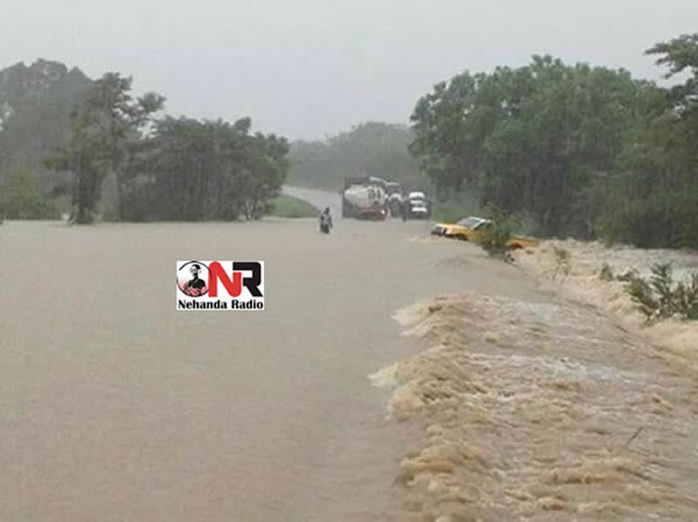
File picture of flooding in Zimbabwe
Of the 56 deaths, 48 are from drowning while eight people died after being struck by lightning. Matabeleland South police spokesperson Inspector Philisani Ndebele confirmed seven deaths from his province and urged people not to attempt to cross flooded rivers.
“We always advise people not to attempt to cross flooded rivers. Parents should also watch their children because two of the seven cases we recorded are of children under the age of 10 who drowned in flooded rivers.
“Although we haven’t recorded any cases of people who drowned while fishing, we advise people including motorists to keep away from flooded rivers,” he said.
According to a report compiled by the Civil Protection Unit (CPU), six people died while attending a funeral while a 10-year-old pupil was also struck in Binga. The last case where one person was killed by lightning was received in Dzivarasekwa, Harare.
CPU acting director Mrs Sibusisiwe Ndlovu said people should take precautions and try by all means to be safe whenever there was lightning.
“People should avoid going outdoors when there is lightning, and keep clear of windows, electrical equipment, pipes and other metal objects. They should avoid bathing when it is raining because water is a conductor of electricity.
“In case it starts raining while outdoors, people should seek shelter inside a car or solid building; avoid using umbrellas which have metal handles. We also advice people that if they are far from shelter, they must avoid being the tallest objects, and crawl with their feet together, if possible in a low area. If there is more than one person, they should avoid standing in groups, instead, they spread out and crouch,” she said.
She also said people should avoid being in open areas or spaces.
“At all costs no one is supposed to shelter under an isolated or cluster of trees, they should also try to avoid riding in open vehicles, tractors, bicycles, and donkeys or scotch carts. If swimming or in a boat, when it starts raining they should get out of water and seek shelter immediately.
“People struck by lightning can survive if first aid is administered until professional help is sought,” said Mrs Ndlovu. Sunday News

