You are here: Home › News › Lightning kills 18 cattle

Lightning kills 18 cattle
February 20, 2017 in News https://www.newsday.co.zw/2017/02/20/lightning-kills-18-cattle/
THREE families from Chikomba district in Mashonaland East province, were left shell-shocked on Saturday after their 19 beasts worth about $10 000, succumbed to a bolt of lightning.
Own Correspondent
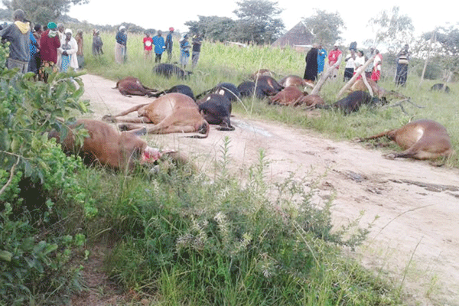
Chikomba villagers mill around 18 head of cattle that died after they were struck by lighting on Saturday
Mable Njowa of Masendu Village lost 10 beasts, while brothers Masiyiwa and Martin Juru of Munhundorima village lost four beasts each in a mid-afternoon incident that has left villagers in panic.
Chikomba district acting livestock production and development officer, Cosmas Ratsakatika, said the incident occurred close to the families’ homesteads in headman Neshangwe’s area, 60km north-east of Chivhu.
The incident came shortly after a bolt of lightning killed two students and injured 83 others at Chinatsa Secondary School in Marondera district, last month.
Ratsakatika said, two years ago a Feasterstone farmer lost nine head of cattle under similar circumstances.

REPLY
NACIDO RICO February 20, 2017 at 12:46 pm #
Avenging spirits. Try to find out who in your tribe killed a human being.

