**Protection from lightning (Zimbabwe)**

By Ronald Watts.

<https://learn.tearfund.org/en/resources/publications/footsteps/footsteps_41-50/footsteps_44/protection_from_lightning/>

Tropical countries throughout the world have considerably more lightning strikes than cooler countries. High exposed plateau areas with few trees seem to receive more lightning strikes than other areas. When people live in thatched huts the risks are higher. Zimbabwe holds the record for the highest number of people killed by a single flash of lightning, with 21 people killed in one hut near Mutare in 1975.

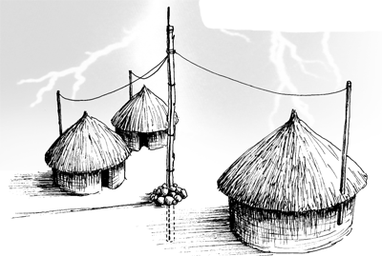

Lightning is called ‘an Act of God’ since no-one can predict where it will strike. However, the causes of lightning have a straightforward scientific explanation. If lightning strikes a person, it can cause the heart and sometimes the lungs to stop. Hearts may restart without medical help but if lungs have also stopped, heart massage and mouth-to-mouth resuscitation may be needed urgently to revive the person and prevent death.

In many countries people believe lightning is associated with witchcraft. This means that many people are afraid to help anyone struck by lightning in case they are affected. More lives could be saved if people were taught that lightning is a natural process and there is no risk from helping anyone who has been struck. Giving heart massage and mouth-to-mouth resuscitation immediately might save some lives.

In large open spaces anything upright, especially if made of metal, is more likely to be hit by lightning – single trees, poles, fence posts and even a person. If you are caught in an exposed area, move away from open water and look for a ditch to lie down in! The safest place to shelter is under a large group of trees (choose a shorter tree) or in a closed vehicle (where the rubber tyres provide protection).

If well-built houses with water pipes and electricity are struck by lightning, the electrical power will pass along the metal pipes and wires, avoiding people inside. However, in thatched buildings the lightning will pass through the people inside. Researchers found that thatched kitchen huts were much more likely to be struck by lightning because of all the metal pots. Avoid sheltering in kitchens!

All buildings, especially those with thatched roofs, could be protected by providing a ‘lightning conductor’. This is a very tall wooden pole at least six metres high, standing at least 1.5 metres from a building. Tie galvanised steel wire along the length of the pole extending beyond the end of the pole both on the top and in the earth. Bury the pole at least 1.5 metres deep and pile rocks at the base to protect animals or children from receiving a shock during a lightning strike. If the ground is rocky or built over, lightning conductors can also be attached to trees. Where a number of houses are close together, the same lightning conductor can protect many houses. Attach shorter poles to the side of houses (not dug into the ground) and link these by wire to the main conductor.

Make sure the poles are taller than the top of the house roof. If lightning strikes the area, it will strike the metal wire on the conductor and be passed safely into the earth without damaging people and homes. Ronald Watts worked in Zambia and other African countries for many years promoting agriculture and sustainable development. He now lives in Maes Yr Eglwys,

*Ronald Watts worked in Zambia and other African countries for many years promoting agriculture and sustainable development. He now lives in Maes Yr Eglwys, Penycae, Swansea, SA9 1GS, UK.*