**Landslide kills 5 in Ivory Coast as weather agency issues ‘red alert’**

Anadolu Agency [**WORLD**](https://www.anews.com.tr/world)

Published June 11,2023

https://www.anews.com.tr/world/2023/06/11/landslide-kills-5-in-ivory-coast-as-weather-agency-issues-red-alert#:~:text=issues%20'red%20alert'-,Landslide%20kills%205%20in%20Ivory,weather%20agency%20issues%20'red%20alert'&text=At%20least%20five%20people%20of,Ivory%20Coast%2C%20rescue%20services%20said.[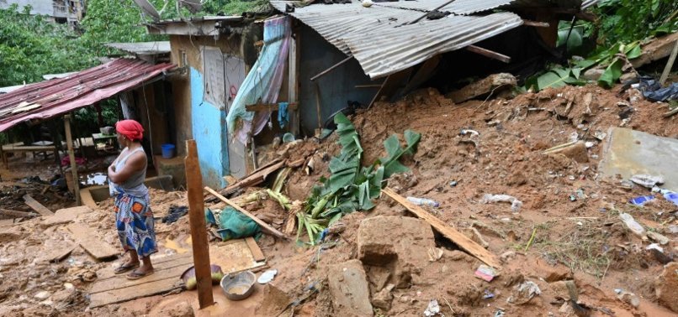](javascript:;)

*A resident is seen at the site of a landslide that killed a family of five in the Yopougon district of Abidjan on June 11, 2023. (AFP Photo)*

At least five people of a family were killed in a landslide on Sunday following overnight heavy rains in Abidjan, the economic capital of Ivory Coast, rescue services said.

The incident happened in the Mossikro sub-district in the commune of Attecoube, the government's alert platform Police Secours said, adding that the dead included a couple and their three children.

No further damage was reported. But torrential rains hit several Abidjan suburbs in the night from Saturday to Sunday, Ivorian meteorological agency Sodexam said.

The rains reportedly left roads completely flooded in many parts of the city.

Sodexam issued a "red alert" for the Yopougon district of Abidjan, signaling more heavy rains and flooding.

Some 15 children were killed and two others injured in Ivory Coast from January to June 6, 2023, from disasters triggered by heavy rains, according to official data.

The death was attributed to flooding, lightning, collapse of houses and drowning in streams among others.

Last year, 19 people died in the country following torrential rains.