Lightning kills teenage boy in Malawi
https://www.sott.net/article/375108-Lightning-kills-teenage-boy-in-Malawi
Malawi24
Tue, 23 Jan 2018 09:45 UTC
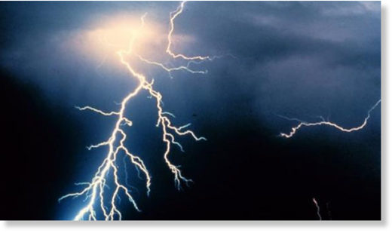
A 14 year old boy in Nkhotakota district has died after being struck by lightning.
The boy, Yesaya Banda, is reported to have been killed by the lightning on his way to the lake for fishing.
Confirming the reports, Nkhunga Police spokesperson Ignatius Esau said Banda opted to go for fishing with his friend Mabvuto Phiri aged 12 on Monday.
"On their way, heavy rains started and lightning struck the two," said Esau.
He added that well wishers took the two boys to Ngala health center where Yesaya was pronounced dead while Mabvuto was referred to Nkhotakota District hospital for further treatment.
Esau has since advised members of the area to remain indoors when it is raining.
Yesaya was from Mwandimba village, Traditional Authority (TA) Kanyenda in Nkhotakota district.

