Lightning kills albino Catholic priest in Benue - Nigeria
https://dailypost.ng/2023/10/12/lightning-kills-albino-catholic-priest-in-benue/
October 12, 2023
By Sunny Green Itodo
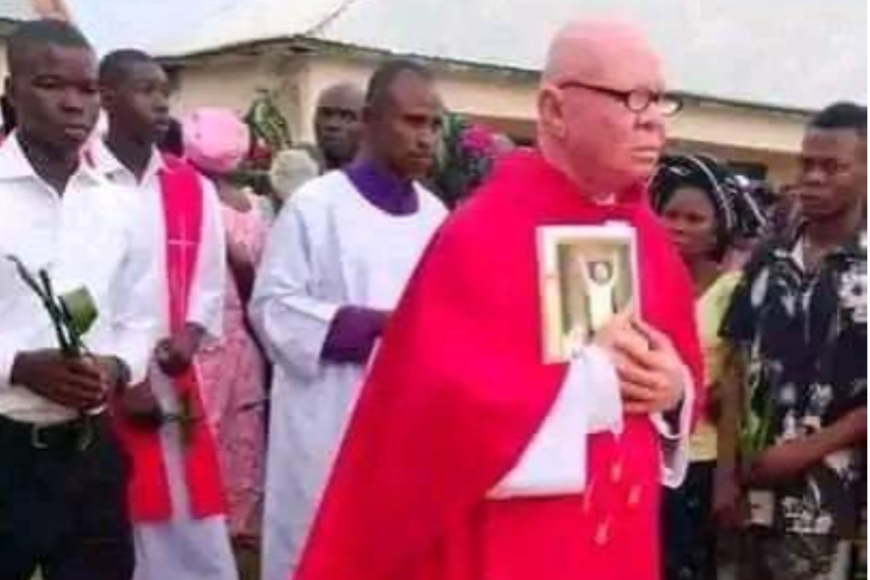
Lightning has reportedly killed a Catholic priest identified as Rev. Fr. Faustinus Ukenongo Gundu in Benue State.
According to eyewitness reports, Gundu, an albino, was struck by lightning and died on the spot on Thursday.
The incident happened at his church in Jootar Mbaterem in Mbayenge Ward of Ukum Local Government Area.
Gundu was said to be the Parish Priest in charge of St. Joseph Catholic Church Jootar until his reported sudden death.
An eyewitness, Emberga T. Joseph, posted in a popular Facebook group, Benue News Link Makurdi: “Black Thursday. Thunder lightning killed Rev FR. GUNDU (ABINO) Benue state Ukum LGA. Rest in peace.”
Another eyewitness, Aga Linus, wrote on his Facebook page: “Just in, Thunder strike and killed the parish priest in charge of Jootar in Ukum LG Rev. Fr Gundu. May your soul rest in peace Rev.”
Similarly, Olikita Ekani, a former media aide to the immediate past governor of the state, Samuel Ortom, also posted about the incident on his Facebook page.
He wrote, “Just in: Rev. Fr. Gundu slumps to death as thunder hits Jootar.
“Until his demise today, Rev fr. Faustinus Ukenongo Gundu (fondly called Albino) was the Parish Priest of St. Joseph Catholic Church Jootar, Ukum LGA of Benue State.
“May his soul rest in perfect peace!”
Scores of parishioners and other mourners flooded the comment sections of posts about the incident with farewell notes to the Catholic priest.
Efforts by our reporter to get the police to confirm the incident proved abortive as the spokesperson of the Benue State Police Command, Catherine Anene, did not respond to calls and messages.

