Lightning kills 35 rare falcon chicks worth Dh1.1m [UAE]

50 rare birds valued at Dh20 million killed in lightning at barn in Abu Dhabi
Owner has gone on record to correct figures stated in earlier reports

Published: March 25, 2019 18:41 - Aghaddir Ali, Staff Reporter

https://gulfnews.com/uae/weather/lightning-kills-35-rare-falcon-chicks-worth-dh11m-1.62883254

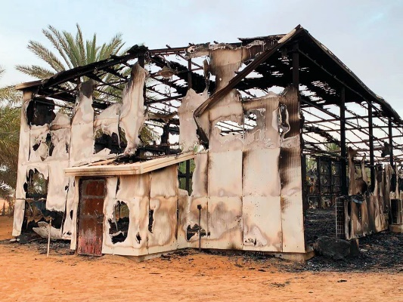

Abu Dhabi: A lightning thunderbolt that hit a barn in Al Dhafra on Sunday morning killed 50 rare birds and caused total financial losses of Dh20 million (about $544,000), according to the barn’s owner Khalfan Bin Butti Al Qubaisi, speaking to the Arabic press.

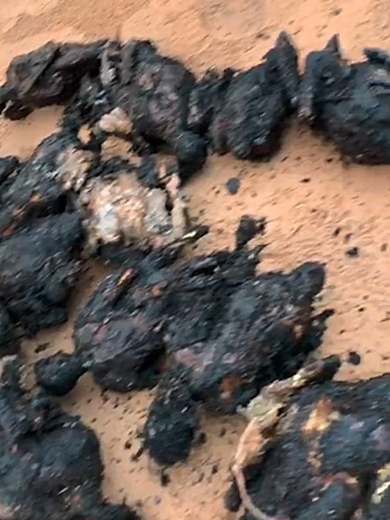
Charred remains of the rare falcon chicks.

Initial reports said that 35 rare falcon chicks had been killed in the lightning strike costing Dh1.1 million.

The owner has since gone on record to correct the figures and said the birds were priceless and were trained to compete in high level falconry tournaments. One of the birds was a famous competition winner valued in excess of Dh10 million alone. “The thunderbolt was very strong and burned everything,” he said. “The bird nests and building became a pile of ashes and the birds were roasted in the painful incident.”

