HERO of the MONTH

February 2024

Daniel Esteban Villamil Sierra

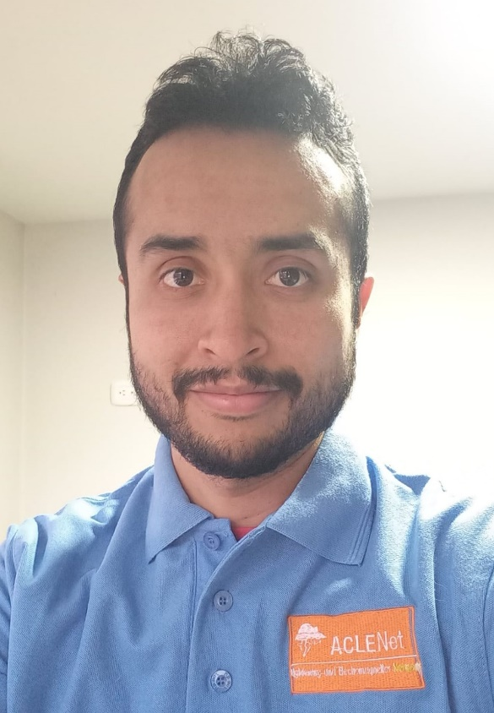

- What is your background?

Electrical Engineer, specialized in Geographic Information Systems Implementation, and MSc. of Engineering. Author and co-author of several books and papers related to lightning safety. Member of the Research Group on Electrical Systems and Energy Efficiency (GISE3) and the High Voltage and Lightning Research Hotbed (SATDEAT) of the Universidad Distrital Francisco José de Caldas in Bogotá, Colombia. Since 2012, he has been working on research to promote lightning risk prevention and in 2016 he was awarded the Young Scientist Award by the Scientific Committee of the 33rd International Conference on Lightning Protection (ICLP 2016) for his presentation on the role of lightning risk in the context of Disaster Risk Management. He is currently the CEO of the Latin American Lightning and Education Network (LALENet), an NGO that seeks to decrease deaths, injuries, and property damage from lightning in the region.

- How and when did you hear about ACLENet?

I met Professor Mary Ann Cooper 10 years ago when my research about lightning safety was just starting. From that day on we have built a fruitful friendship in which we support each other’s projects. Therefore, I’ve been following ACLENet's updates from the very beginning.

- What motivated you to work with ACLENet?

I feel a strong sense of compassion and concern for the well-being of others, especially when it comes to preventable tragedies like lightning-related deaths and injuries. Working with ACLENet provides me an opportunity to make a tangible impact and save lives in the African region.

- Please describe your work with ACLENet.

I serve as a reporter of the lightning-related injuries news from Portuguese-speaking African countries by collecting them from news websites and then translating them into English. Moreover, I am the translator of the African Flash Newsletter into Spanish.

In addition, I've been a co-author of some papers about the work of ACLENet, including one I presented in person at the 15th International Symposium on Lightning Protection (XV SIPDA) in São Paulo, Brazil.

- What are some of your key achievements so far with ACLENet?
I've been involved in organizing and conducting lightning safety awareness campaigns across various communities raising the ACLENet flag. This has led to fostering partnerships and collaborations with other lightning safety advocates, resulting in the creation of the sister organization for Latin America LALENet.

- What are some of the challenges you have encountered in your work with ACLENet? How have you addressed these challenges?

Language diversity in the African region presents communication challenges. I’m honored to take advantage of my knowledge of Portuguese to handle the information from the Portuguese-speaking countries.

In addition to the above, obtaining accurate and up-to-date lightning-related injury reports is challenging in most countries of the world, including Africa. This has been addressed by developing a large database that is fed by filtered news reports in real-time thanks to the use of Google Alerts.

- How would you like to see ACLENet develop in the future?

I hope to see ACLENet expand its reach across the African region, reaching more communities, especially in remote and underserved areas. It is my wish to see ACLENet's initiatives have a lasting impact on lightning safety. Therefore, I would like to see ACLENet forge strong partnerships with governments, meteorological agencies, other NGOs, academic institutions, and private organizations to enhance our resources, knowledge, and outreach capabilities Ensuring that the safety measures and education implemented are sustained over time will effectively reduce lightning-related deaths, injuries, and property damage in the long run.

- What do you see in the future for ACLENet regarding lightning safety?

In the future, I envision ACLENet continue becoming a driving force in lightning safety across the African region. With the collective efforts of dedicated volunteers and staff, I see ACLENet expanding its reach through widespread awareness campaigns and educational programs, empowering communities with the knowledge to protect themselves from lightning hazards. By forging strong partnerships with governments, meteorological agencies, and other NGOs, ACLENet can continue developing a comprehensive approach to lightning safety, leading to a significant reduction in lightning-related deaths, injuries, and property damage. Additionally, I anticipate ACLENet's focus on data collection and research to provide valuable insights, enabling evidence-based strategies and policy advocacy to strengthen lightning resilience at various levels. As ACLENet gains recognition and support, I believe the organization will continue to innovate in its outreach methods, leveraging technology to engage diverse audiences, and inspiring a culture of safety and preparedness.

- Encouragement note

Dear fellow lightning safety advocate,

Your dedication and commitment to supporting ACLENet's mission in reducing deaths, injuries, and property damage from lightning in the African region are truly commendable. Your efforts as a volunteer may play a vital role in raising awareness, educating communities, and fostering a safer environment for all. Your passion for this cause and the impact of your work may also inspire many to strive for greater achievements in the future. Remember that every life saved and every community empowered through your efforts is a testament to the positive change you are bringing to the region. Keep pushing forward, for together, we can make a significant difference in protecting lives and ensuring a brighter, safer future. Your contributions are invaluable, and we'd be grateful to have you as part of the ACLENet team. Let's continue our journey with enthusiasm, knowing that our collective efforts will continue to save lives and create a lasting impact in the African region.

- Is there anything else you would like to include – personal information, family, goals, etc? Is it ok to list your email?

I'm happily married to 5 years ago with the best woman in the world and I've got a beautiful 2-year-old daughter. With God's Blessing, I hope to continue working the rest of my life for preventing deaths and injuries from lightning whenever needed.

THANK YOU for all you do for ACLENet and for saving lives - MA

