60 students struck by lightning while in class - Kenya
Today at 12:25 PM, 3 March 2019
https://www.pulselive.co.ke/news/60-students-from-st-brigid-nangwe-in-kabuchai-bungoma-county/nenyhsb
60 students from St. Brigid Nangwe in Kabuchai, Bungoma County were on Sunday struck by lighting while they were in class studying.
Fransiscah Munyasia, who is the school principal of the girls school, stated that the incident occurred when the students were in for their evening preps.
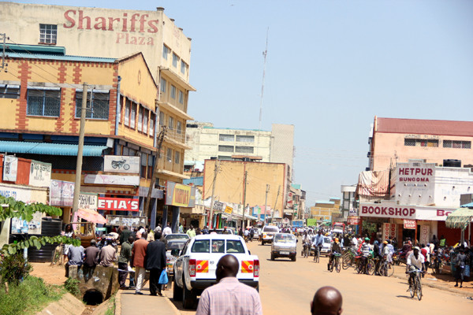Bungoma town on a busy day
The girls had been rushed to Khalaba Medical Centre in Bungoma town to receive treatment.
“The incident happened when the girls were conducting their evening preps. The lightning struck and certain girls started calling for help.
“We rushed those injured to hospital and 50 have been treated and returned to school,” remarked Munyasia.
Munyasia stated that ten out of the sixty had been kept in hospital for further treatment.
A medical officer at the hospital, Michael Milimo, explained that the ones admitted had suffered burns from the accident.
“They suffered burns as a result of the lightning but they are responding to treatment and we are hoping that they will be discharged soon,” stated Milimo.
Lightning kills footballer during goal celebration
In December 2018, a footballer was killed by lightning while six other team mates were left injured in Funyula, Busia County, during a football match.
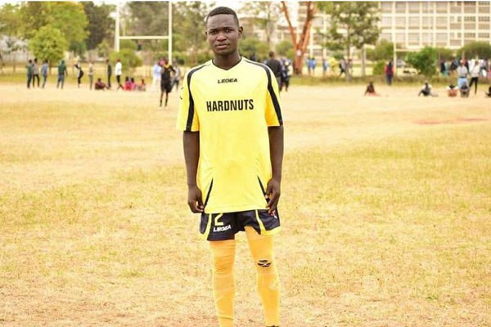
Allan Mbote of Red Sharks FC
Allan Mbote was struck by lightning during a goal celebration during the launch of the Nangina Ward Soccer tournament at Luchulo Primary School grounds.
Funyula OCPD Mary Kiarie had confirmed the incident and revealed that three of the players had been rushed to hospital and were recovering well while the other three were treated and discharged.
Author: Mark Mwithaga Source: Pulse Live Kenya

