WATCH: Zimbabwe school children wade through floods as 'shocking death toll emerges'
2017-03-04 13:00
News24 Correspondent
https://www.news24.com/Africa/Zimbabwe/watch-zimbabwe-school-children-wade-through-floods-as-shocking-death-toll-emerges-20170304
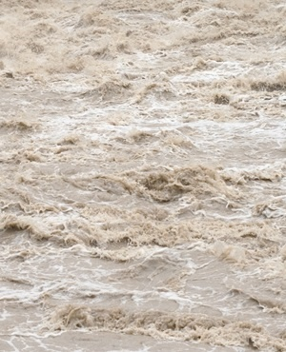
Harare - Record-breaking rains in Zimbabwe have left at least 246 people dead and more than 2 000 displaced - but they've also had a devastating effect on schools in several parts of the country.
The death toll is cumulative and covers all those who've drowned or been struck by lightning in Zimbabwe since the start of the rains in October last year, according to a written statement from Local Government Minister Saviour Kasukuwere seen by News24.
Floods took a sharp turn for the worse after tropical storm Dineo swept through swathes of the south of the country two weeks ago. But there were also more rains last weekend, and they've brought misery to communities that until recently were struggling to keep going in the midst of a devastating drought.
Dozens of schools now need new ablution facilities after theirs were destroyed while tents are needed to replace classrooms, Kasukuwere said as he appealed in Harare on Thursday for help from the international community and Zimbabweans in the diaspora.
"Classrooms, tents, stationery, furniture and text books are needed," the minister said. "Some teachers' cottages were destroyed making them unfit for human habitation."
In a video clip that's been widely circulating on social media platforms in Zimbabwe, children from Lundi High School are seen carrying buckets, suitcases and umbrellas as they wade through flooded water to safety last week. Hostels at the school, in south-eastern Mwenezi district, were flooded and members of the army had to be brought in on Monday night to rescue 23 members of staff who'd been marooned "when their houses were surrounded by water," according to the official Chronicle newspaper.
Watch the video below.
Commenting on the footage, Raymond Majongwe, the head of the Progressive Teachers Union of Zimbabwe said on Twitter: "Something needs to be done. Life of these kids is in danger." He said that too much media attention had been paid to President Robert Mugabe's 93rd birthday party on Saturday and not enough to the real stories of devastation endured by villagers and schoolchildren because of the floods.
The state Zimbabwe Broadcasting Corporation says that $100m is needed to repair the roads, schools and hospitals that were destroyed.

