Lightning kills three family members in Tharaka Nithi (Kenya)
https://www.nation.co.ke/counties/tharaka-nithi/Lightning-kills-three/3370192-4326694-t3v46f/index.html
SATURDAY MARCH 3 2018

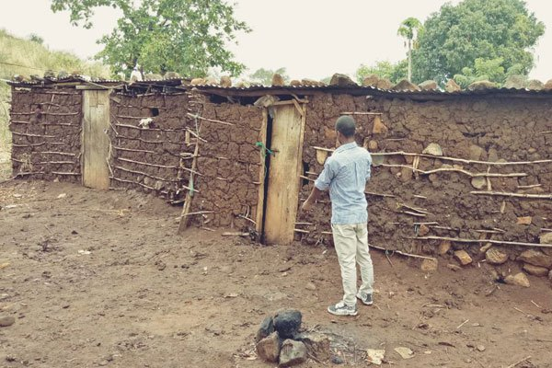
The houses where a woman and her two children died after she they struck by lightning in Tharaka Nithi County on Friday. PHOTO | ALEX NJERU | NATION MEDIA GROUP
In Summary
- Heavy storms have ripped through many parts of the country in the past few days, leaving a trail of destruction.
ADVERTISEMENT
By ALEX NJERU
More by this Author
A lightning strike has killed a woman and her two children in Kamujwa village, Tharaka Nithi County, authorities say.
Tunyai Chief Julius Mburio said the woman, her son and her daughter were struck while they were inside their house on Friday at around 8pm.
The boy was a Form Three student while the girl in Standard Eight.
Heavy storms have ripped through many parts of the country in the past few days, leaving a trail of destruction.
Earlier this week said Kenyans should brace themselves for heavy rainfall of more than 50mm in 24 hours starting Thursday.
The downpour, according to the forecast released on Tuesday, will be experienced in western Kenya, Rift Valley, Nyanza and central Kenya.

