HERO of the MONTH

Mitchell Guthrie

October 2023
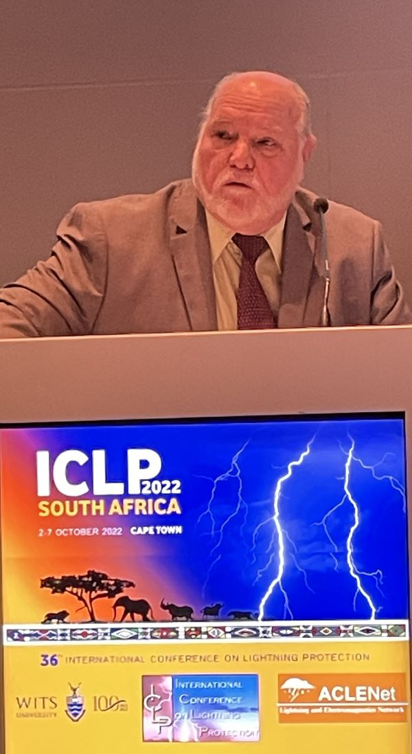

- What is your background?

Upon graduation from NC State University, I went to work at a US Navy R&D laboratory to join the Electrical Explosives Safety team. I was responsible for grounding, protection against lightning, personnel and helicopter generated electrostatic discharge, and intrinsic safety. This led to representing the Navy/D0D on lightning protection standards committees such as NFPA, UL, DoD, NATO and IEC. During this time, I served a tenure as Chair of both NFPA 780 and IEC TC 81 Committees on Lightning Protection.

I have served on high profile DoD, commercial, and international forensic analysis teams related to incidents with potential causes related to lightning and electrostatic discharge.

- How and when did you hear about ACLENet?

I have followed the work of Dr. Cooper for a long time. I was made aware of the formation of ACLENet at an ICLP. When we heard about their intention to protect schools in Uganda in locations having documented lightning safety issues, a small group of LPI members concluded we could support the design process remotely and volunteered to participate in the LPWG.

- What motivated you to work with ACLENet?

I am in a position that allows me to participate, feel I can make a difference and it is the right thing to do. I have always been an advocate of lightning safety and thought I could provide a skill set that would support their lightning protection efforts and help identify affordable implementation, maximizing available resources, while meeting the intent of international lightning protection standards.

- Please describe your work with ACLENet.

I am heavily involved in the collection of data for new projects, design of lightning protection systems for schools and other lightning safe havens, and interfacing with the in-country team to implement the installations. I also provide support to Executive Committee members in discussions on expanding the scope of ACLENet in the incorporation of lightning protection requirements at Ministry, country, regional, and Pan-African levels.

- What are some of your key achievements so far with ACLENet?

My key achievements are tied to team achievements and program milestones met. Those that I consider notable are:
- The completion celebration of the installation at Shone Primary School. This was the proof of concept that the process developed would work and all challenges could be overcome.
- Completion of Palabek Senior Secondary School installation
Palabek had larger and greater number of structures and provided more design challenges with shared earthing systems.
- Completion of Rock View Primary School installation.
This was a significant increase in number of structures (17) and complexity of designs and installations.
- Completion of Mongoyo Primary School installation.
This installation tested the abilities of the team to react to adversity, requiring design changes during the installation phase. We overcame the presence of rocks in the vicinity of the teacher’s quarters, a large church with a headwall topped by a cross, and several thatched roofs. A highlight was the introduction of mast-type LPSs made from in-country materials.
- Hôpitaly Vaovao Mahafaly Consultation (Madagascar)
This is a key achievement because it is the first consultation effort with an NGO that followed through identification of components required, with installation to be the responsibility of the hospital. This model relieves the burden of the purchase of materials and labor for installations from ACLENet to the NGO.
- To me, the most significant achievement to date was the prominent role that ACLENet played at the 2022 ICLP in Cape Town and the week of meetings before the conference.
  - Prior to traveling to Cape Town, Dr. Cooper and the Uganda team met with key people and organizations including Ministers and their staff introducing ACLENet and making valuable contacts.
  - The 4 members of the Uganda team attending the ICLP took care of an ACLENet booth and networked with attendees during the conference.
  - Numerous papers were presented detailing aspects of ACLENet’s efforts, which were well received.
  - A highlight of the conference was ACLENet’s Barnabas Akantambira’s Closing Remarks during the Closing Ceremony.
  - To me, that was the most significant fortnight to date in documenting the viability of ACLENet.

- What are some of the challenges you have encountered in your work with ACLENet? How have you addressed these challenges?

- Initially, communication was the biggest challenge. Accents were issues on both sides. From the US we had members from southeast, northeast, northern central and southwest US. Both sides had to get used to regional/national terminology. It took a while to get used to Ugandan accents and enunciation, compounded by all communication being via Zoom. This was made easier by limiting vocabularies, initially. Non-technical terminology was difficult but was resolved over time.
- Another challenge for the US team was a lack of experience of Uganda in-country challenges. An abundance of pictures helped mitigate these problems but working through these issues made the process much slower than would be normally expected. The decision to start with a small and simple school enabled the team to work through the process and become comfortable with the process of working together. The 2nd school was larger and offered new challenges that led to an evolution of the process and gave the team more confidence.

- How would you like to see ACLENet develop in the future?

- I am comfortable with the leadership of the organization and their focus for the future. I don’t think a primary focus specifically on protection of schools will lead to a successful future as an organization due to budget and manpower issues, but we could act as a facilitator for those better equipped to perform these functions. I don’t think this means ACLENet abandons such efforts, but instead we better define what role we can play in continuing the effort. We could use upcoming installations at Lake Victoria schools to see if it can be a model for how we can provide local logistics and on-site support as necessary.
- One area we can develop is to support the existing infrastructure in countries, some directly with the national authorities and others through NGOs in establishing and implementing lightning safety plans We can provide any necessary interface for organizations or companies that would like to donate resources to protect schools.
- A long-term goal should be to evolve from regional support to Pan-African. Options to make this happen are being explored.

- What do you see in the future for ACLENet regarding lightning safety?

I see ACLENet expanding from a focus on protecting schools in Uganda to making a Pan-African impact. We are uniquely equipped to work with countries, regions and NGOs in the implementation of lightning protection standards tailored to their needs. I see this as a way to also address tailoring the lightning risk assessment to conditions applicable to rural Africa versus industrialized countries and modern cities reflected in IEC 62305-2, Edition 2.

- Encouragement note

The Lightning Protection Working Group has evolved into an efficient team. They communicate well, have complementing skills and positive attitudes. I feel comfortable with the ability of the team to meet the challenges they may face.

I am extremely encouraged by the expanding network of lightning safety organizations and the willingness of each to share information and resources to reduce the number of lightning deaths and injuries worldwide.
- I encourage others to contact your regional network to see how you can help or request their support in providing material you can use to spread the message in your village or sphere of influence.
- To those with means, I encourage you to contact your regional network to see how you can support the effort to save lives.
- To those that have done so, I send my sincere appreciation.
Editor’s note: Sister programs to ACLENet in other areas of the world are the South Asian Lightning Network (SALNet) and Latin American Lightning Education Network (LALENet)
- Is there anything else you would like to include – personal information, family, goals, etc? Is it ok to list your email?

esecmg@embarqmail.com

