Lightning kills 21 cows - South Africa- North West
March 17, 2023
https://www.news24.com/news24/southafrica/news/we-suffered-a-great-loss-farmer-loses-large-part-of-income-after-lightning-kills-21-cows-20230317

'We suffered a great loss': Farmer loses large part of income after lightning kills 21 cows

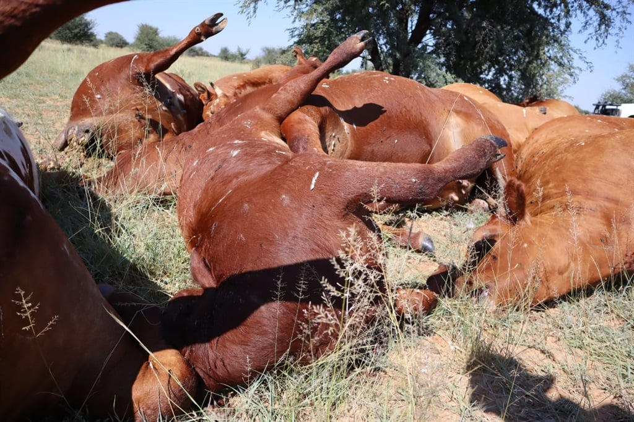
Twenty-one cows were struck by lightning on a North West farm.
Thusoitsile Lobaleng
- North West farmer Vincent Lobaleng lost 21 cows after they were struck by lightning on Wednesday.
- Lobaleng said the cows were valued at around R260 000.
- Eleven of the cows were pregnant.
The cows, worth around R260 000, were struck by lightning during heavy rain on Wednesday.
The owner of the cattle, Vincent Lobaleng, said 16 cows and five calves died at his Entry Farm near Morokweng.
Lobaleng lives in Morokweng and visits the farm regularly to assist the helper, who lives on the farm and looks after the cattle full time.
Lobaleng's nephew, Thusoitsile Lobaleng, said the helper discovered the carcasses on Thursday evening.
"My uncle was fixing the fence at the farm on Thursday when he heard 10 of his cows mooing endlessly. He then asked our helper to find out what was wrong. The helper responded and said they were probably restless because they were separated from the other cows," said Thusoitsile.
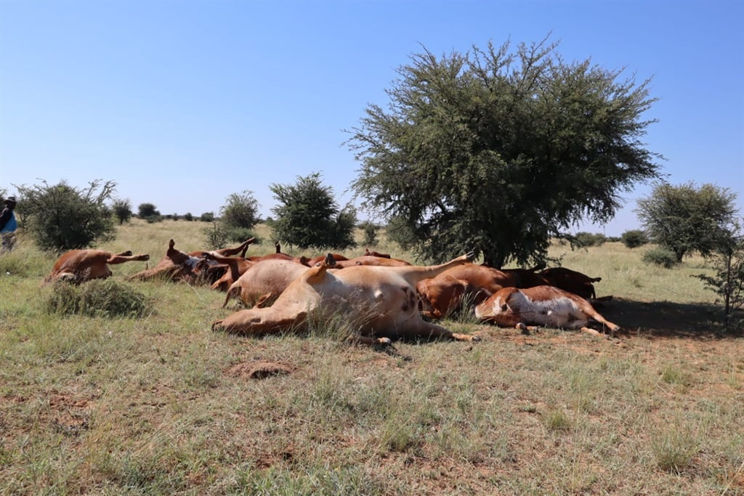
He said his uncle didn't pay much attention to it and went home. He later received a call from the helper, who informed him that the cows had died.
"The helper said he tried to call my uncle as soon as he discovered the dead cows, but due to load shedding, there was no network, thus, he only found out in the evening," he added.
Thusoitsile said the cows were not insured.
"At the moment, we're trying to get help to dig graves so we can bury them. Cows that were struck by lightning can't be eaten, so this is a big loss," he added.
Thusoitsile said the family was pleaded for help from the relevant departments and stakeholders.
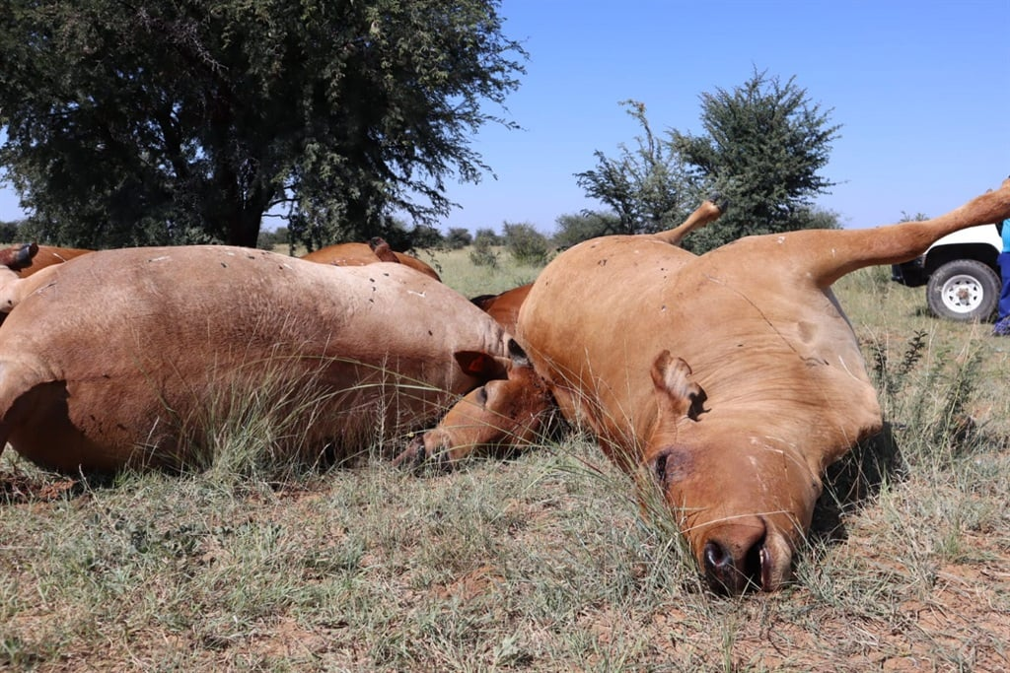
"We suffered a great loss, and especially my uncle. He lived off these cows as he would sell them time and again. We don't know what's next and how he'll move on from this," said Thusoitsile.
Lobaleng is left with 10 cows.

