Daily Monitor
Here’s how to keep safe from lightning – UGANDA
WEDNESDAY SEPTEMBER 22 2021 By ESTHER OLUKA More by this Author Daily Monitor
https://www.monitor.co.ug/uganda/news/national/here-s-how-to-keep-safe-from-lightning--3558888
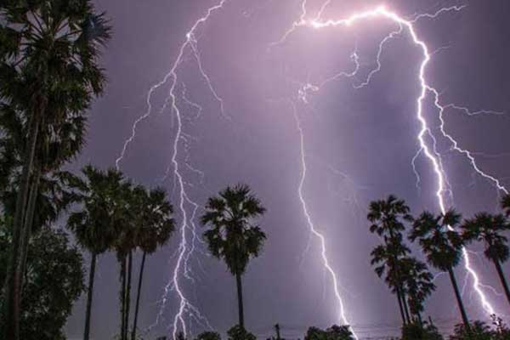
Experts have advised the public to take extreme precaution against lightning during the ongoing rainy season. Photo | File
Summary
“This lightning (a visible electrical discharge) happens when there is an imbalance either within the clouds themselves or between the clouds and ground,” Mr Nicholas Kwarikunda, a lecturer of physics at Makerere University, said.
----------------
Experts have advised the public to take extreme precaution against lightning during the ongoing rainy season.
During an interview yesterday, the experts said chances of lightning are often higher when it is threatening to rain or when it is already raining.
“This lightning (a visible electrical discharge) happens when there is an imbalance either within the clouds themselves or between the clouds and ground,” Mr Nicholas Kwarikunda, a lecturer of physics at Makerere University, said.
He added: “On some rare occasions, lightning may also occur when there is no rain.”
Oftentimes, lightning tends to strike structures with sharp points or objects that are on high ground.
“That is why it is not advisable to continue standing on raised ground, for example a hill, when it is raining,” Mr Kwarikunda said.
He warned people against standing near good conductors of electricity such as power lines and barbed wire fences.
Those who take shelter inside houses are also advised to take precaution.
“Try to avoid anything that could easily transmit electric sparks from lightning. Don’t do things like touching water, ironing, using electric cookers, make calls using landlines or be near anything concrete,” Mr Kwarikunda said.
Instead, people are encouraged to find any wooden item that can be used for either sitting or resting.
ADVERTISEMENT
Individuals staying in raised buildings have also been urged to install lightning rods on their structures as these help to transmit electric sparks to the ground which eventually get neutralised.
Meanwhile, driving fast during a thunderstorm may also turn out to be dangerous.
Mr Benon Fred Twinamasiko, another physics lecturer at Makerere University, said: “Drive slowly so that there is a little disconnect between the body of the car and the wet surface (as water tends to be a good conductor of electric sparks from lightning).”
Explaining how lightning kills, Dr Alex Kakoraki, a general practitioner at Murchison Bay hospital in Luzira, Kampala, said it is because this visible electrical charge generates electric power, which passes through the body and causes different impacts.
“It mostly leads to the body system getting shocked which eventually results in death,” Mr Kakoraki stated.
He added: “Some people survive even after being struck because the magnitude might have been less at the time.”
September to December weather
These preventive measures are being given following the latest reports of people getting killed because of lighting.
For instance, NTV Uganda on September 3 reported that five family members in Omoro Sub-county, Omoro District, were struck by lightning while sleeping in their grass-thatched house.
In a September 2 statement, Mr David Elweru, the acting executive director of the Uganda National Meteorological Authority (UNMA), said the months of September, October, November, and December (SOND period) constitutes the second major rainfall season over most parts of the country.
“In general, most parts of the country are expected to experience near normal (average) to below normal (suppressed rainfall) during SOND 2021 season. There is high expectation for poor rainfall distribution over most parts of the country during this season. However from September to mid-October, the rainfall performance is expected to be enhanced,” Mr Elweru said in the statement.
The rainfall, according to the statement, is expected to continue until the end of September.
Rules to protect against lightning strikes
Dos
•Find a safe enclosed shelter when it is raining.
•Install a lightning rod on a high building.
•Stay away from using any kind of electric gadgets or objects.
•Stay away from any water body for instance swimming pools.
•Follow forecasts to get abreast with weather patterns.
Don’ts
•Do not stand on elevated surfaces such as hills.
•Do not stand under high objects such as trees.
•Do not drive fast amidst a heavy thunderstorm.
•Do not lay flat on a concrete ground.
•Do not lean against concrete walls.
eoluka@ug.nationmedia.com
