Thunder Kills 2, Severely Injures 4 in Kanungu - Uganda
September 22, 2021 Moses Agaba | REDPEPPER Correspondent
https://sgq.io/l/513SnTcv
https://www.redpepper.co.ug/2021/09/thunder-kills-2-severely-injures-4-in-kanungu/
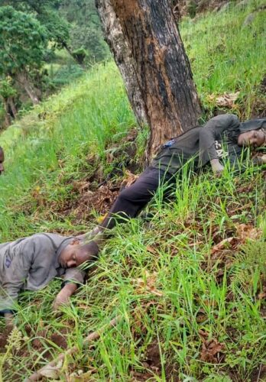
Kanungu | Pepper News – Two people were on Tuesday afternoon struck dead by lighting and Four severely injured in Kanungu district.
Edidiya Turyayebwa, 42 and Kajowa Diyana, 31, died on the spot after they were struck dead by lightning.
Flora Nyinakiiza and her three children namely; Susan Ayebazibwe 16, Friday Akandwanaho 5 and Kirungi Blessings – all residents of Omunsyokwe village, Kyamukende Parish, Kinaaba sub-county Kanungu district, sustained injuries as they were in their gardens digging.

Elly Maate, the Kigezi Regional Police Spokesperson, confirms the incident and revealed that it happened at around 2 pm as the injured are family members of one of the deceased persons Turyayebwa Edidiya and the second deceased had gone to help them in the garden.
Maate says that police has commenced the investigations as the OC Kinaaba visited the scene and arrangements to remove the dead and the injured ones for medical attention are underway

