Lightning kills one, injures another in Muleba District [Tanzania]

By Shaaban Ndyamukama @TheCitizen TZ news@tz.nationmedia.com

FRIDAY, AUGUST 24, 2018

http://www.thecitizen.co.tz/News/Lightning-kills-one--injures-another-in-Muleba-District/1840340-4727660-14j7a55/index.html
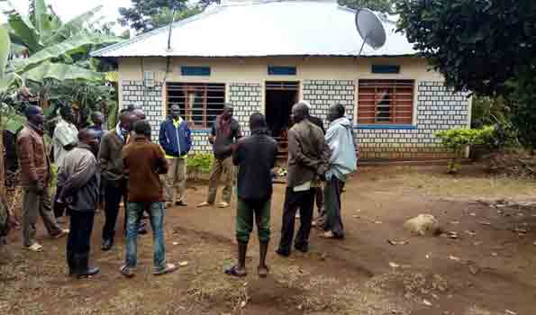

Muleba. A Standard Two pupil Belina Bonofas, 9, at Kagoma Primary School died here on Friday, August 24, after she was severely burnt by a lightning.
The incident occurred at around 9.15am at her home in Kikuku Ward, Muleba District, Kagera Region when it was raining, according to her guardian Renaus Pastory.
The deadly lighting hit the child burning her entire body, this happened as she waited for breakfast before rushing to school, he said.
Kagoma Primary School head teacher Jeremia January said the pupil was of of the 115 Standard Two pupils and that the entire school was saddened by her death.
Also, the reports have it that, the lighting injured another student of Kagoma Secondary School here. The victim was rushed to Kagondo Hospital for treatment.

