Man killed by lightning in Kakamega as nine injured [Kenya]
Thursday December 20 2018
By Benson Amadala
https://www.nation.co.ke/counties/kakamega/Lightning-kills-man-in-Kakamega/3444890-4903520-nv1xdrz/index.html
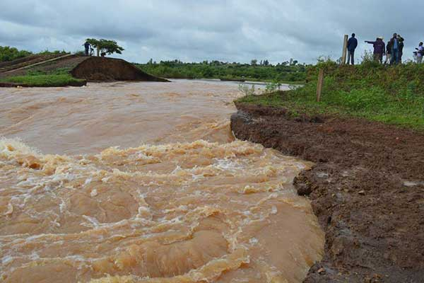
River Yala. A man, who was among several people who had gone to prospect for gold in the river, was on December 19, 2018 struck dead by lightning as he sheltered from the rain in the nearby Emanyonyi village in Kakamega County.

A man was struck dead by lightning while nine other people were injured in Kakamega County during heavy rains on Wednesday.
The villagers, who had gone prospecting for gold along the banks of River Yala, sheltered from the rain at a nearby home in Emanyonyi village, Khwisero Sub-County at around 4.30 pm when the tragedy struck.
They had gone to shelter at the home of Isaac Lipule whose wife and three children were injured in the incident which also left two cows dead.
The man killed by lightning was identified as Nashon Moyi aged 46 years from Mushinaka village.
LOUD BANG
The walls of the semi-permanent house developed cracks after the strike which was followed by a loud bang.
Assistant Chief Peter Oyengo said the injured sustained burns.
"Those badly injured were those without shoes. They had gone to the home to shelter from heavy rains when the house was struck by lightning, killing one of them on spot," said the administrator.
Khwisero OCPD Lanet Sili said the injured were rushed to Khwisero Health Centre for treatment and were reported to be in a stable condition.
"The villagers had spent the day prospecting for gold along the river bank and when it started raining heavily, they went to the neighborhood for shelter," said the police boss.

