Lightning kills three pupils in Kibaale [Uganda]

Thursday June 27 2019

https://www.monitor.co.ug/News/National/Lightning-kills-three-pupils-Kibaale-/688334-5173910-uit5xqz/index.html

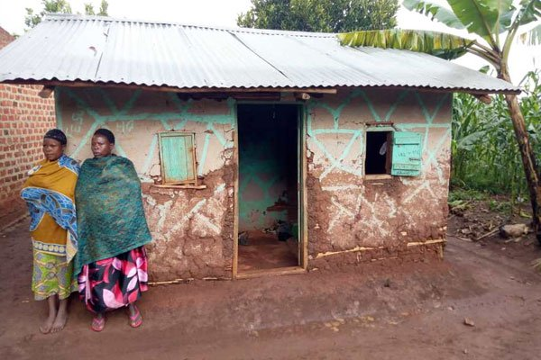
Relatives stand near the house where three pupils were struck dead by lighting in Kibaale District. PHOTO BY FRANCIS MUGERWA
ADVERTISEMENT
By Francis Mugerwa
Kibaale
Three pupils were Wednesday struck dead by lightning in Kibaale District, western Uganda.
Police and residents identified the deceased as Robert Zabayo, a 14-year-old pupil at Kisalizi primary school, his brother Mbabazi Marina, 6 and a friend Moses Alinaitwe, 10.
Zabayo and Mbabazi were children of Obed Byomugisa while Alinaitwe was a one Ayebale’s son, both residents of Kyenkonge village in Kyebando Sub County.
The three had taken shelter at Byomugisa's home when they were struck during the Wednesday evening downpour.
The pupils had just returned from school and were playing in the compound when it started raining. They reportedly sought shelter on a veranda of Byomugisa's home.
"They were killed by lightning and bodies are at Kyebando health centre pending postmortem,” said Mr David Otabong, the Kibaale District Police Commander.
Police visited the scene and recorded statements from eye witnesses.
Mr Otabong asked parents and local leaders to install lightning arresters on all buildings.
In June 2011, lightning killed 18 pupils of Runyanya primary school in Kiryandongo District, leaving over 100 others injured.
editorial@ug.nationmedia.com

