**Shock as peculiar lightning strikes Amolatar-Uganda**<https://www.radiocomnetu.org/hotfm/2024/06/05/shock-as-peculiar-lightning-strikes-amolatar/>

5 June 2024

By Sarah Ejang and Desire Ocen

*Amina Akello, another resident of Bangala who witnessed this incident told Hot FM news that despite lack of rain , a strange event occurred in Lake Kyoga, resulting in a lightning strike that hit Etemu’s home on Tuesday morning reducing it to ashes.*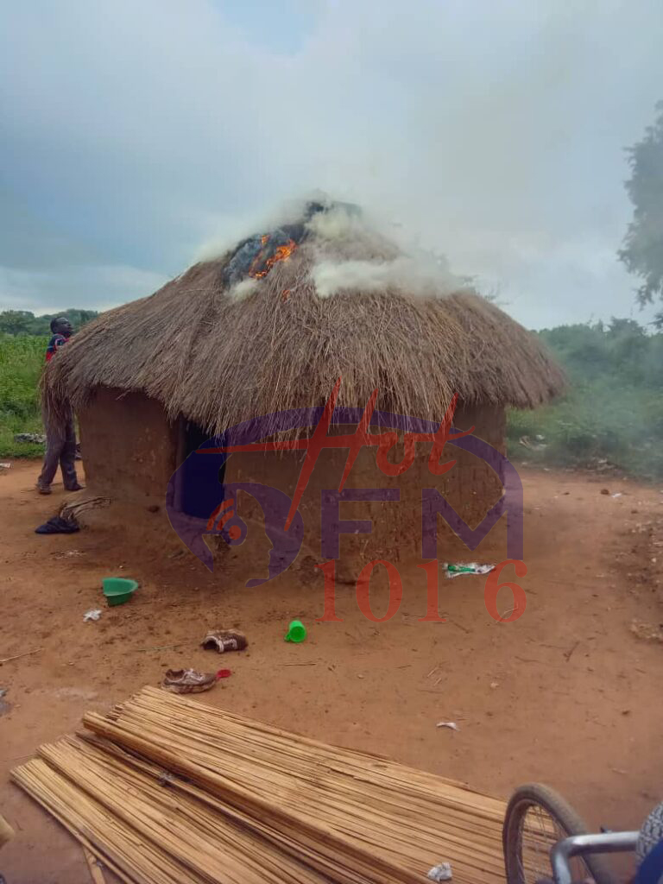

Figure 1 Emetu's hut struck by lightning

A strange bolt of lightning from Lake Kyoga struck a grass thatched house on Tuesday Morning.

The incident left the people of Bangala A village, Bangala Parish, Namasale sub county, Amolatar District in shock.

According to reports, after the strike, one house began to burn down to the ground.

Etemu Peter, the owner of the affected house said that he was inside when this incident occurred.

Etemu added that his wife and children were not home by the time of the incident.

Etemu was however left unconscious for several hours.

He regained his conscious on Wednesday morning after some rituals were performed on him.  
  
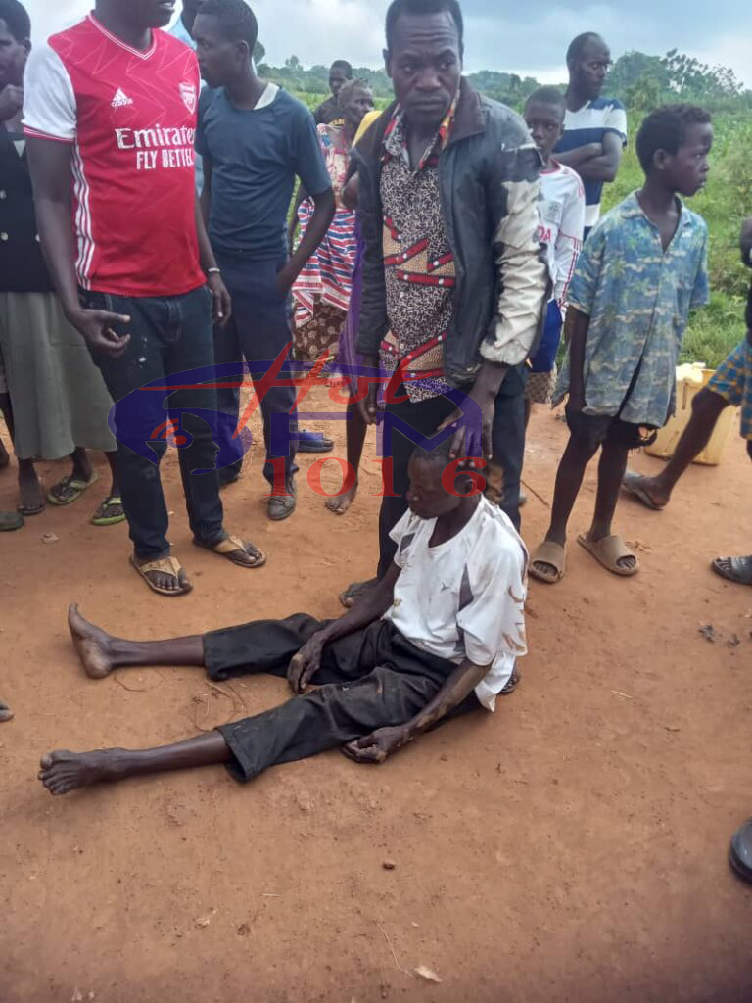

Figure 2: Emutu before regaining his conscious

Amina Akello, another resident of Bangala who witnessed this incident told Hot FM news that despite lack of rain , a strange event occurred in Lake Kyoga, resulting in a lightning strike that hit Etemu’s home on Tuesday Morning reducing it to ashes.

Bosco Olumu , an elder and Etemu’s neighbor , said that the strange lightning struck around 10:30am.

‘’When such phenomenon occurs in the lakes, strong winds usually sweep across the land, causing damage to houses, this happens after every two years,’’ Oluma added.