**Inyemera WFC, Rambura match abandoned as lightning injures 10**

Rwanda

<https://www.newtimes.co.rw/article/13733/sports/football/inyemera-wfc-rambura-match-abandoned-as-lightning-injures-10>

Saturday, January 13, 2024

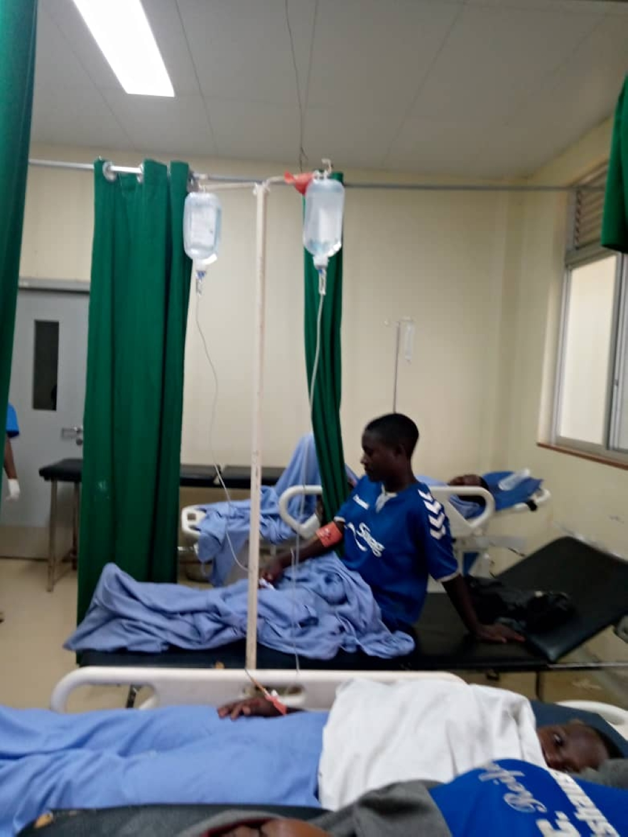

The match between Inyemera WFC and Rambura WFC junior teams in Gicumbi District has been abandoned after lightning struck at Gicumbi Stadium, leaving 10 people injured.

The incident occurred on Saturday, January 13, at Gicumbi stadium in Byumba Sector, Nyarutarama Cell, Nyarubande Village VIII.

At around 12:30 PM, Rambura were leading Inyemera 1-0 until the 65th minute when lightning struck the pitch on a rainy afternoon.

Eight players were hurt, including six from the Rambura WFC namely Diane Uwimaniduhaye (15), Jeannine Isubirizihe (15), Olive Uwayisaba (15), Deline Kaze (19), Umulisa Gisubizo (15), and Valentine Uwiduhaye (17).

Their head coach Jean de Dieu Niragire and club team manager Marie Gisele Umutoniwase were also injured.

Meanwhile, Inyemera WFC junior players also had Devotha Niyokwizerwa (16) and Clarisse Mutuyimana (17) hit by the lightning.

Match officials decided to postpone the match and those hit by the lightning were taken to Byumba Hospital for emergency medical treatment.

Ancille Munyankaka, the commissioner in charge of women's football at the local football governing body (FERWAFA), told Times Sport that affected players and coaches are recovering well and are expected to be discharged from the hospital within 24 hours.

"All the players are currently doing well, and they are feeling better with the assistance of the doctors,” Munyankaka said.

After the incident, she said, some players experienced a rise in blood pressure, but it has now returned to normal.

Rambura Team Manager Umutoniwase was the hardest hit as the lightning left her injured and paralyzed.

“Despite this, she is feeling somewhat better and is expected to be discharged from the hospital along with others tomorrow, if everything goes well," she said.