21 dead from a single lightning strike — and four more new weather mortality records
By Angela Fritz May 19, 2017
https://www.washingtonpost.com/news/capital-weather-gang/wp/2017/05/19/21-dead-from-a-single-lightning-strike-and-four-more-new-weather-mortality-records/?utm_term=.9921dba630cd
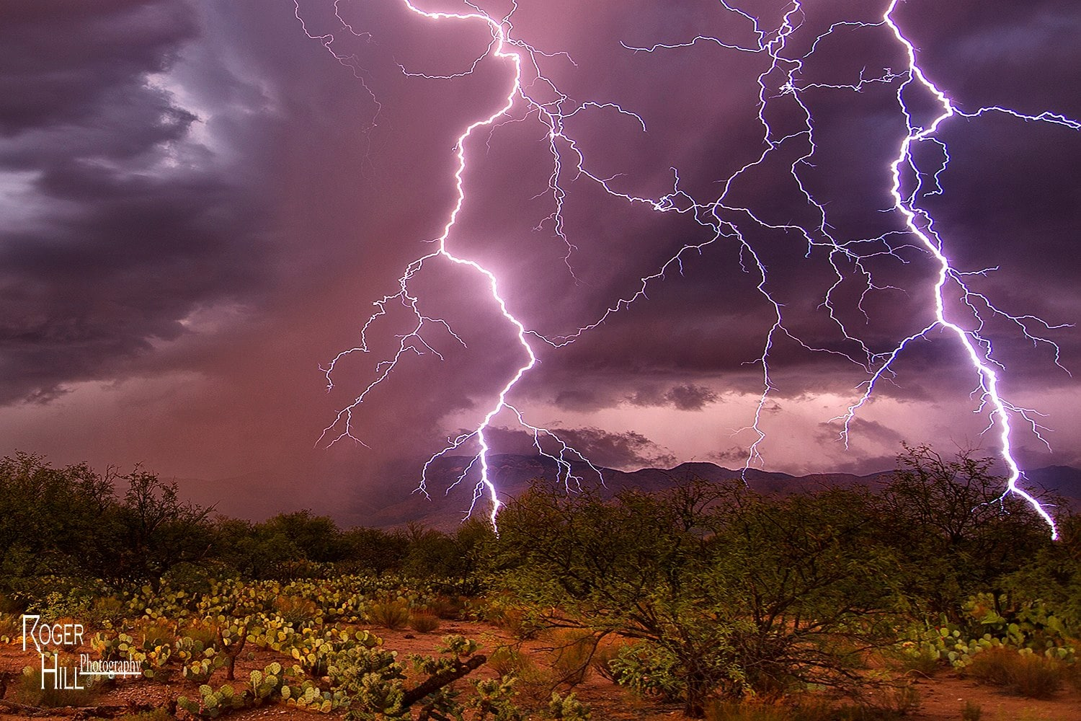
Five global weather mortality records have been certified by the World Meteorological Organization. (Roger Hill Photography)
On Dec. 23, 1975, a strong storm bubbled up over what is now Zimbabwe. It wasn’t uncommon — sub-Saharan Africa, with its very warm and very humid air, is a breeding ground for thunderstorms.
Odds are the rain was torrential and thunder would have been cracking loudly, because people in the Manica Tribal Trust Lands sought shelter in huts. Then, 21 of them, all crowded into the same hut, were killed when a lightning bolt hit the shelter.
It’s the largest known death toll from a single strike, a record which as of Thursday is certified by the World Meteorological Organization.
Zimbabwe is particularly susceptible to lightning. According to the report, nearly 90 percent of sub-Saharan buildings are simple “mud-brick with thatch or sheet metal roofs held down by rocks,” which made their inhabitants vulnerable to lightning injury or death. Dozens of people were killed by lightning this summer alone, including five students who were inside their school at the time of the storm.
The WMO released the single-strike record along with four other sobering mortality extremes:
- Associated with a tropical cyclone: An estimated 300,000 people were killed directly by a cyclone in Bangladesh (what was then East Pakistan) on Nov. 12-13, 1970.
- Associated with a tornado: An estimated 1,300 people were killed in Bangladesh by the April 26, 1989, tornado that destroyed Manikganj district.
- Associated with lightning (indirect): 469 people were killed in an oil tank fire caused by lightning in Dronka, Egypt, on Nov. 2, 1994.
- Associated with a hailstorm: On April 30, 1888, a severe hailstorm killed 246 people near Moradabad, India, with hailstones as large as “goose eggs and oranges and cricket balls.”
The World Meteorological Organization, a U.N. agency, is viewed as the authority on global weather extremes. While weather history is well logged in the United States, most countries lack the resources and organizations to keep track of such things. The organization is why we can say, “It’s a record.”
“Validation of these new world mortality extremes provides solid documentation for many of these deadly events that have not been rigorously compiled in the past,” Thomas Peterson, president of the WMO Commission for Climatology, said in a release.
The organization will use the new records as “base values” for comparison with future deadly weather events.

