HERO of the MONTH

Kimberly Loehr

January 2024

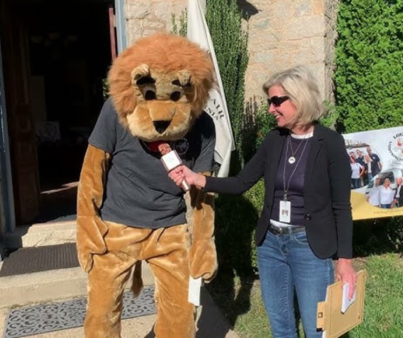

- What is your background?
Answer: My education and career experience is in Journalism and Public Relations, but I’ve always had a keen respect and interest in lightning, as my father owned and operated a lightning protection company (founded in 1947) in Richmond, Virginia. Following in my father’s footsteps, I now co-own and operate the family business, Loehr Lightning Protection Co., after working as a communications consultant within the LPS (lightning protection system) industry for both corporate and nonprofit organizations over the last two decades. Educating people about lightning protection and lightning safety is my passion, and through the years I’ve had the pleasure of partnering with groups like the Federal Alliance for Safe Homes-FLASH, NOAA/National Weather Service and the National Lightning Safety Council to help promote lightning safety awareness.

- How and when did you hear about ACLENet?
Answer: I can’t remember when I heard about ACLENet, but was introduced to the organization by Dr. Mary Ann Cooper, who I knew from the NOAA/NWS lightning safety awareness team and the National Lightning Safety Council. Dr. Cooper introduced me to the organization, and I became interested in ACLENet’s work and its mission.

- What motivated you to work with ACLENet?
Answer: The dedication and passion that Dr. Cooper has shown in helping to protect Africans against the very real dangers of lightning has been truly inspiring. She leads by example with energy and optimism—and luckily for ACLENet her “can-do” attitude can be contagious.

- Please describe your work with ACLENet.
Answer: I’ve served as a volunteer board member since January of 2021, participating in monthly meetings and supporting the mission and efforts of the organization.

- What are some of your key achievements so far with ACLENet?
Answer: My expertise in communications, marketing and PR, along with my working knowledge of the LPS industry have likely been my key contributions to the organization. I’ve helped spread the word about ACLNet’s efforts in news releases and helped promote aspects of its mission in infographics, social media posts and by sharing word of mouth 411 about the organization in partner networking. Hopefully, some of these contributions have helped advance the ACLENet mission to help build lightning safe communities in Africa.

- What are some of the challenges you have encountered in your work with ACLENet? How have you addressed these challenges.
Answer: Obligations to my family business and other trade and volunteer organizations which I belong to and serve, necessitate significant demands—so unfortunately, time to assist ACLENet and its mission is at a premium. It can be a challenge to balance work demands with volunteer interests and expectations, but thankfully, ACLENet is led by an extremely organized and effective director. I’m grateful to work with a mentor like Dr. Cooper who is empathetic and respectful of your volunteer time and encouraging of the expertise you can lend.

G & H: How would you like to see ACLENet develop in the future? What do you
see in the future for ACLENet regarding lightning safety?
Answer: It would be wonderful for ACLENet to be able to expand its building lightning safe communities effort across the continent of Africa. To see lightning safety awareness accepted and incorporated into the African education system and infiltrated into public practice is a life-saving goal worth working toward. More stakeholders and more donations of $, time and talent can help ACLNet achieve this very worthy goal!

- Encouragement note:
Answer: To my knowledge, ACLNet is the only organization in the world which has provided lightning protection systems to fortify school buildings against the deadly and dangerous lightning risk. Despite a host of obstacles, ACLENet has succeeded in making a difference in lightning safety and has likely impacted countless lives by helping to protect some of the world’s most vulnerable communities from an omnipresent weather threat.

- Is there anything else you would like to include – personal information, family, goals, etc? Is it ok to list your email?
Answer: I’ve been very blessed in this life and am grateful for all the connections I’ve made and met in my work in lightning protection and lightning safety. Throughout my life, I’ve sought to enlighten people about the dangers of lightning and benefits of safety standard compliant lightning protection systems in writings, partnership work, speaking engagements and wherever possible. Lightning is my passion and my life’s work. It’s my hope that my modest efforts have made a small difference to help build lightning safe communities here in the U.S., in Africa and around the world.

THANK YOU for all you do for ACLENet and for saving lives – MA

