St. Theresa Kisubi P. 4 dormitory on fire, no injuries but all property gone. by thunder & lightening! [Uganda]
25th October 2023
Link one for video on YouTube - https://www.youtube.com/watch?v=uT1SEqm6yiE
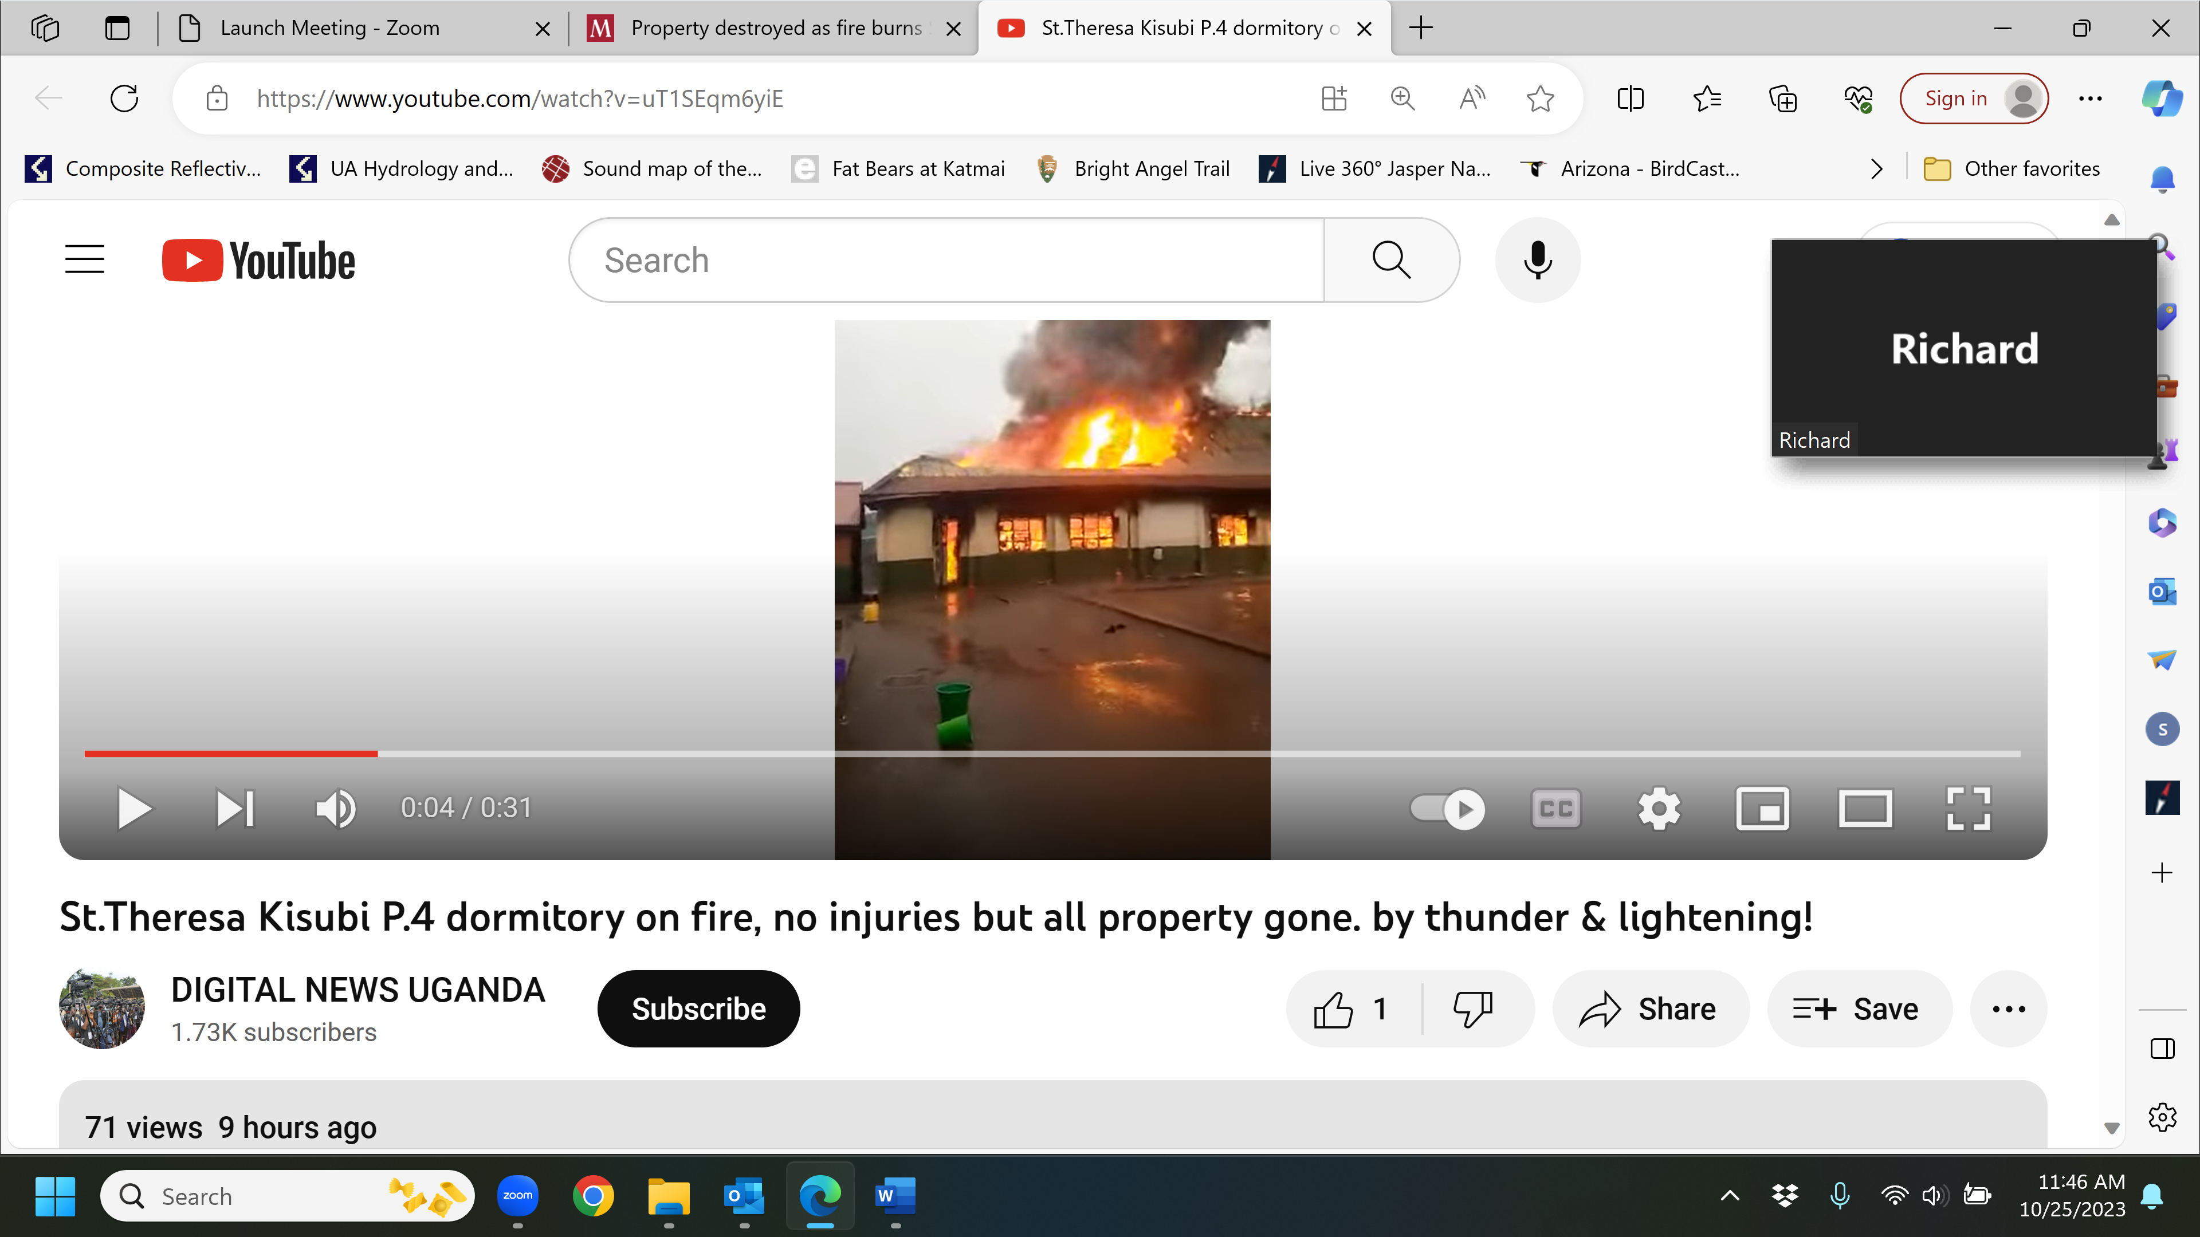
Link two for daily monitor newspaper - https://www.monitor.co.ug/uganda/news/national/property-destroyed-as-fire-burns-st-theresa-kisubi-girls-dormitory-4412926

Property destroyed as fire burns St Theresa Kisubi Girls dormitory
Wednesday, October 25, 2023
The Kampala Metropolitan Police Deputy spokesperson, ASP Luke Owoyesigyire, said the Entebbe Main Police Station has begun investigations to find out the cause of the fire.
There were moments of tension at St Theresa Kisubi Girls’ Primary School after a fire razed down one of the dormitories on Wednesday morning.
According to the school headmistress, Sr Maria Josephine Namubiru, the fire was as a result of lightning that struck the Primary four pupils dormitory during a heavy down pour while the girls where in class.
"We found out from the matron that it had caught fire, all the laborers and staff who were around made an effort to put out the fire using water, sand and the fire extinguishers that are around all the school blocks," she said.
Sr Josephine said they called the police who arrived when the fire had been put out with only a few flames still blowing up.
"We are lucky that all our daughters were in class by the time of the fire, they are all safe, and no child or staff was affected. However, all the property was destroyed," she said.
Sr Josephine said the affected girls have been given counselors to comfort and help them psychologically through the situation.
The Katabi town council LC3 chairperson, Mr Ronald Kalema, said although the dormitory had a lightning conductor, the thunder and lightning were very strong.
"Police arrived late but we want to thank them for coming and putting out the remains of the fire that was threatening to spread to another building," he said.
The Kampala Metropolitan Police Deputy spokesperson, ASP Luke Owoyesigyire, said the Entebbe Main Police Station has begun investigations to find out the cause of the fire.
"It's reported that the fire broke out at 8am, the police fire brigade was called in and responded promptly to put out the fire, luckily no one was hurt or lost life in the incident" he said.

